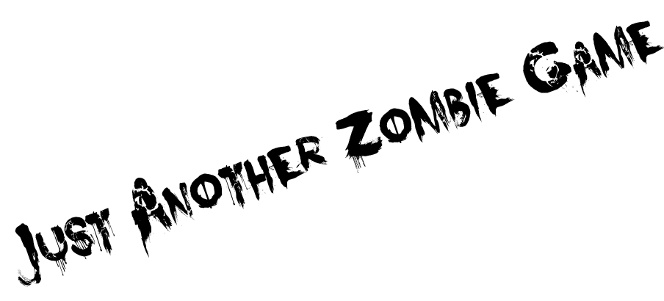
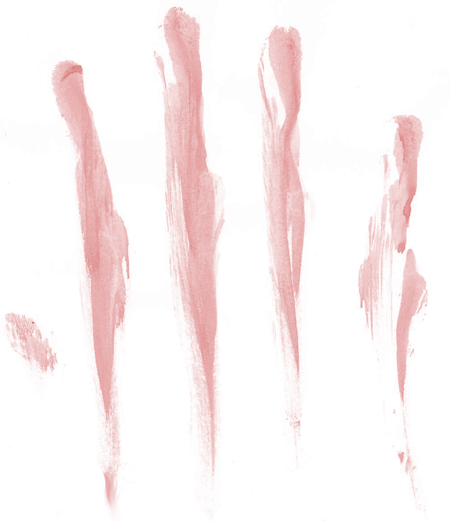
User Guide

By Alex Knowles
Contents Page
2
2
2
4
12
17

22
22
25
25
27
27
28
31
34
35
41
41
43
45
45
47

50

- Technical info
  - Installation
    - Downloading the file
    - Downloading & Installing FileZilla
    - Uploading to the server
    - Creating a webpage for the game

- Player info
  - Finding the game
  - Main Menu
    - Starting The Game
    - Loading A Saved Game
    - Changing Options
      - Controls
      - Sound
  - In-Game
    - Moving
    - Health
    - Picking Up Items
    - Using Items
      - Weapons
      - Foods
      - Fortifications

- Glossary

Technical Info

Installation –

Downloading the file –
First you need to download the game file. This will be sent to you in an email. The sent email should have the same info as below but may look different because of your email client.
Step 1)
Click the attached file JustAnotherZombieGame.swf

Step 2)
A dialog box should popup asking what you want to do with the file. This window should look like bellow but possibly without the image on the left hand side. You need to press the save button before you continue.
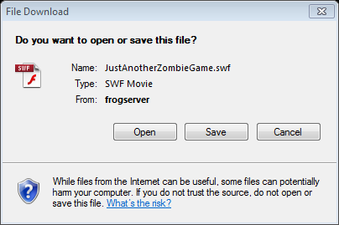

Step 3)
Another dialog box should now appear asking where you would like to save the file. Choose a suitable location on your hard drive to save the file; you will need to remember the location to come back to the file later. Once you have a suitable location, make sure the name of the file name is JustAnotherZombieGame.swf and the save type is an SWF Movie. Now to continue to the next step, press the save button.
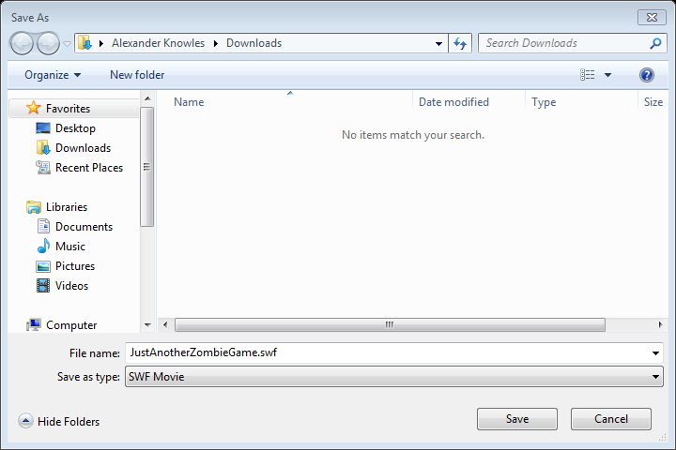
Step 4)
The last dialog box should disappear revealing another box that looks similar to the image bellow. Click the Close button and don’t forget the file location.
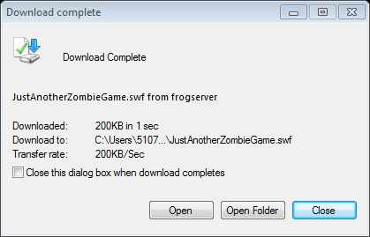

Downloading & Installing FileZilla –
FileZilla is a free and easy way of uploading files to a server. This is why I recommend you download and install it following the steps bellow
Step 1)
Open up your favourite web browser. For the example I am going to use Mozilla Firefox
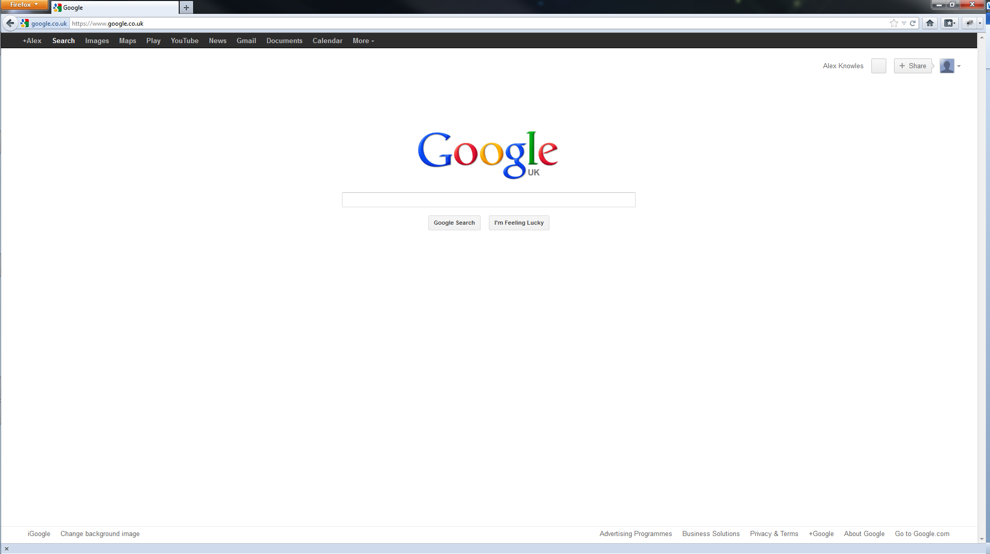
Step 2)
Go to the URL Bar and type in http://filezilla-project.org/. Then press enter or press the go button.

Step 3)
You should have a screen similar to the image below. You need to click where it says “Download FileZilla Client”.
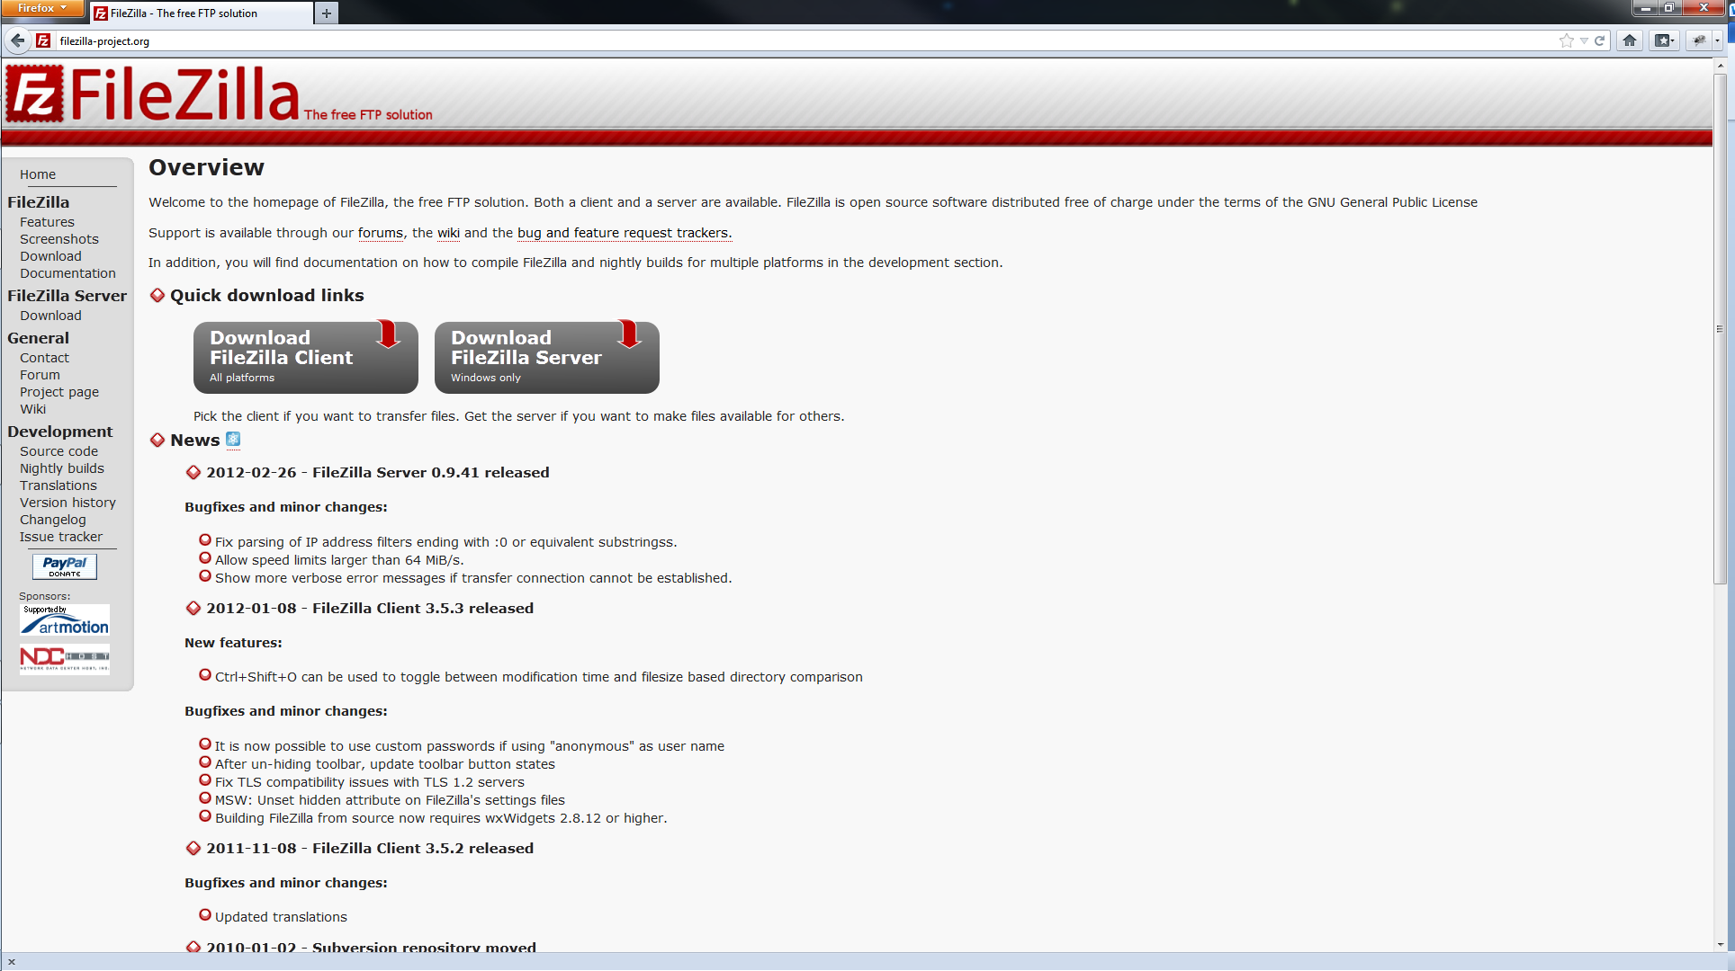
Click Here
Step 4)
After clicking “Download FileZilla Client” you should get taken to the download page of the site. You now need to press the big green “Download Now” button.

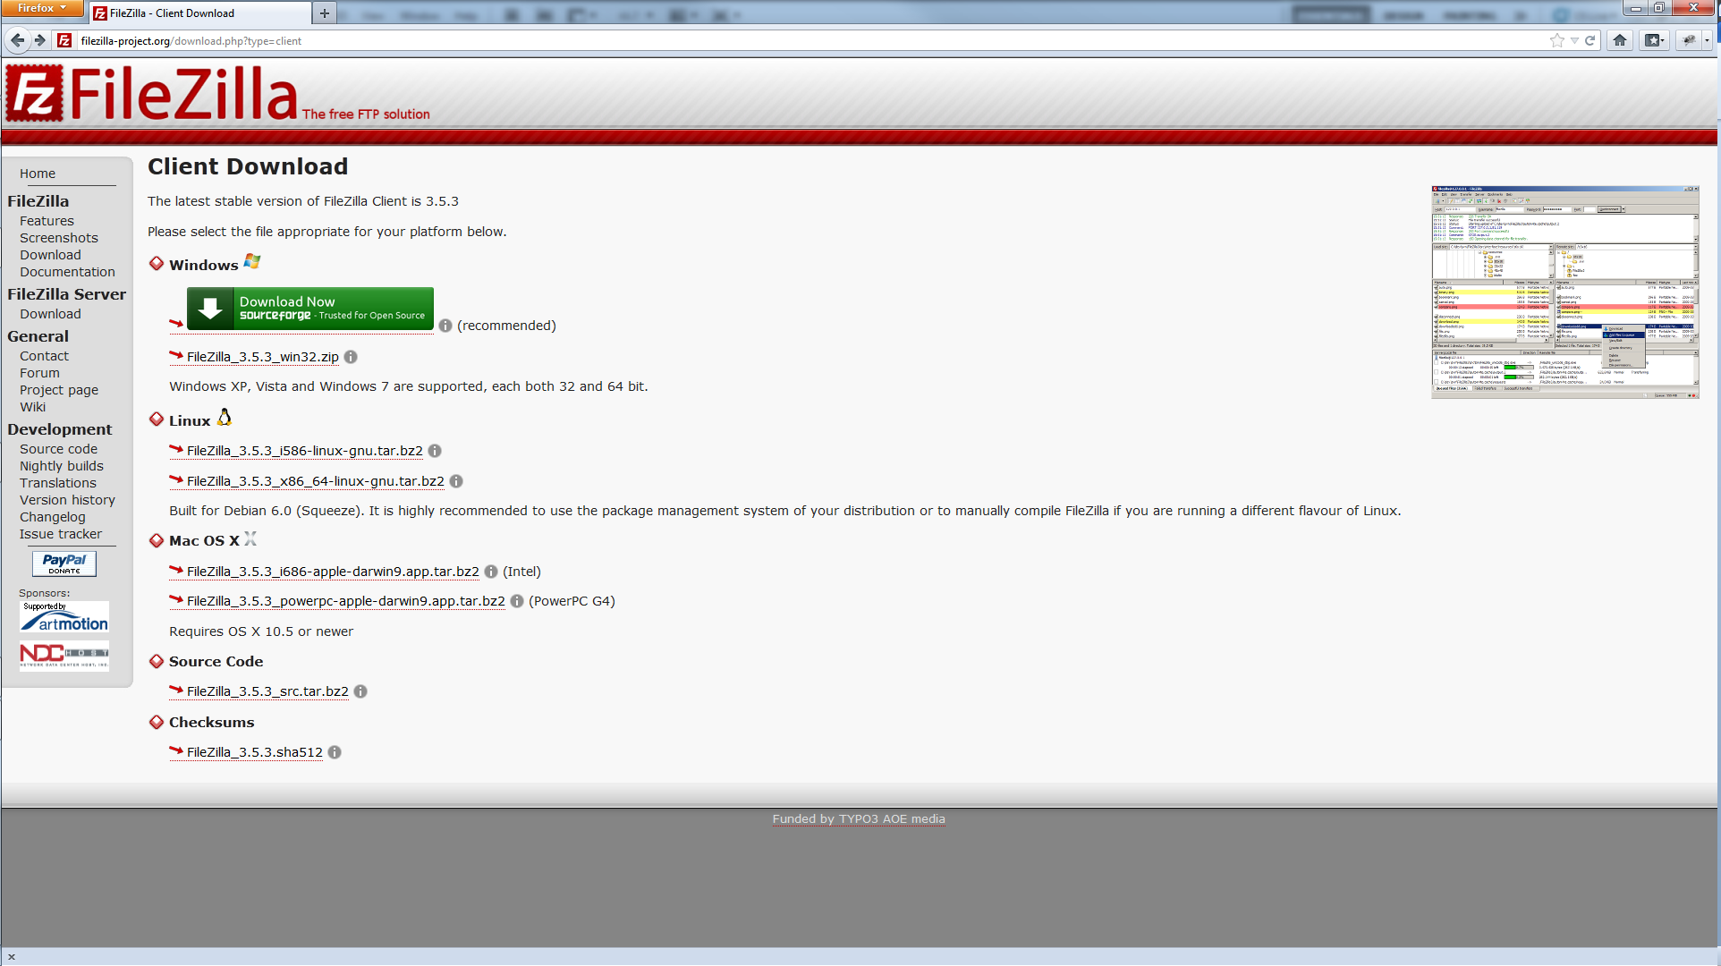

Step 5)
You should get redirected to a web page call sourceforge. This page will then start a download and ask you if you wish to save the file. You need to press Save file.
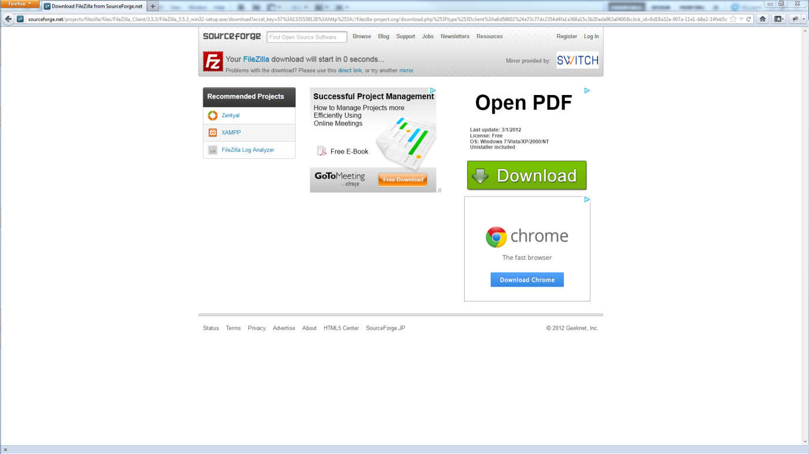
After a few seconds this dialog box should appear

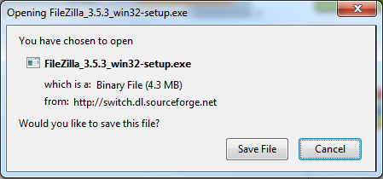
Click Here
Step 6)
Pressing Save File should save the file to your download folder. You need to navigate to this folder and run the saved file. In my case the file is called FileZilla_3.5.3_win32-setup.exe.
Step 7)
A dialog box, like the image bellow, should open up asking if you want to run this program. The program is perfectly safe so just press run. This will then open another dialog box (which I oddly can’t print screen) asking if you want this program to make changes to the computer. Click the yes button on this dialog box.
Click Here
Step 8)
You should now have a setup window for FileZilla Client, like the image bellow. It’s recommended that you read the licensing terms then continue the installation by pressing the I Agree button.
Step 9)
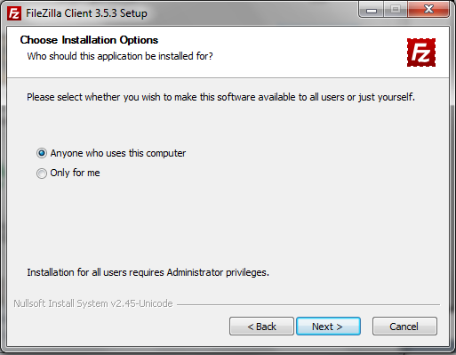
You now get given a choice of who you want to install the program for. It doesn’t matter which option you choose, but I would recommend that you check Anyone who uses this computer. Once you have checked one of the options, proceed to by pressing the Next button.
Click Here
Step 10)
You are given another choice on which components to install. I again recommend that you just check all the boxes but you don’t have to.
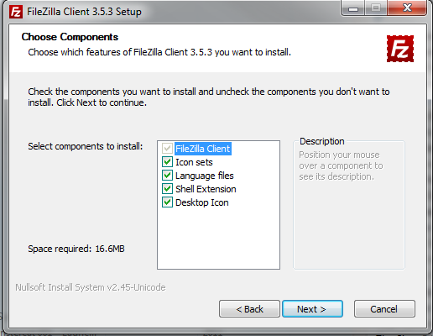
Click Here
Step 11)
Now select a file location where you wish to save the program. I recommend you leave it as the default as it will place FileZilla with your other program files. Click next when you have chosen the file location.
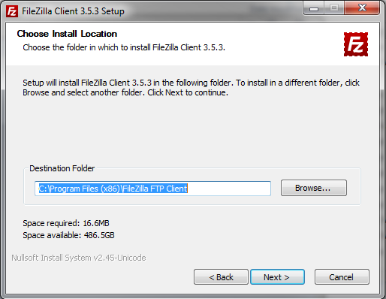
Click Here
Step 12)
Just press Install on this screen as you don’t need to worry about the menu folder.

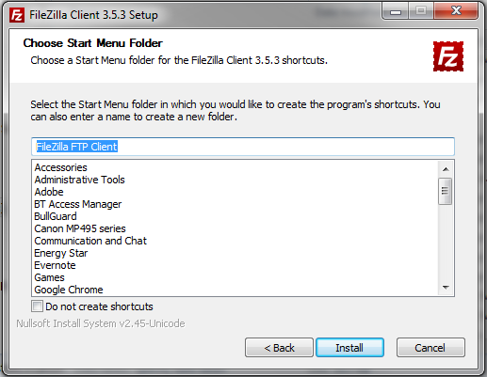
Click Here
Step 13)
The file will now install itself. Once it completes the installation you will be presented with a window like the image bellow. Make sure you have check Start FileZilla now and press Finish.
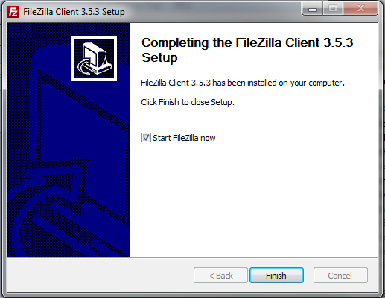
Click Here

Uploading to the server –
Before being able to create a webpage to allow anyone on the internet to play the game, you must put the swf file onto the server.
Step 1)
Now you have completed the installation you should be presented with a window similar to the image bellow. First thing you need to do is navigate to the location of where you saved JustAnotherZombieGame.swf in the left hand file listing.
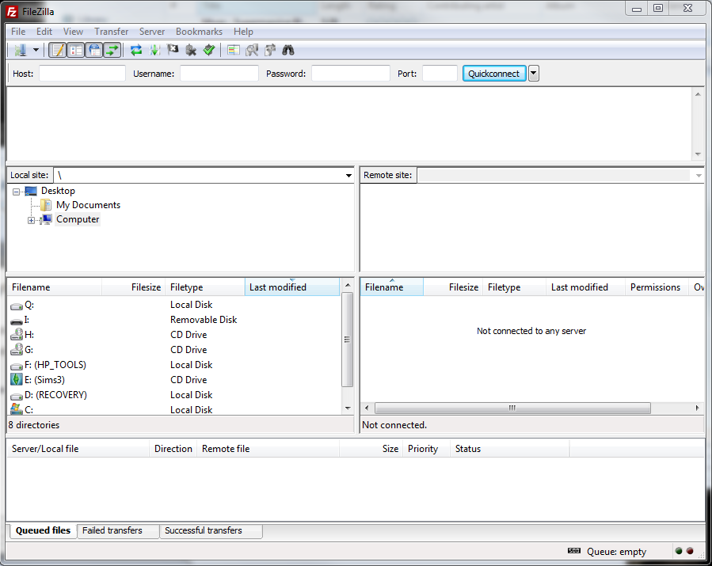
Find the location of JustAnotherZombieGame.swf here

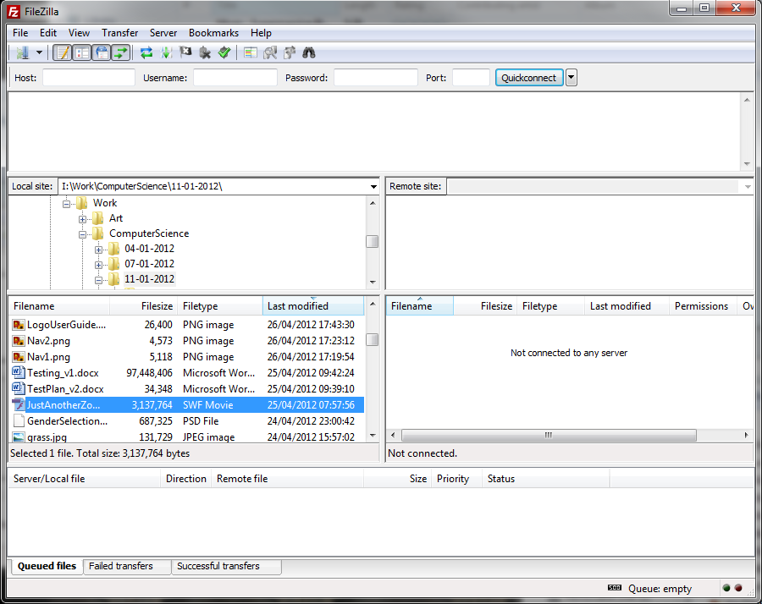

Step 2)
Next step is to connect to the server. I know to connect to knowlesy.co.uk’s server the host is ftp.knowlesy.co.uk, the username is knowlesy.co.uk and well you know the password. You need to fill this information into the top bar and press Quickconnect.

Step 3)
Lots of text should generate in the box bellow the top bar. If everything has gone correctly the bottom line of the box should say Status: Directory listing successful. If it doesn’t say that try pressing Quickconnect button again.

Step 4)
Now you know that you are connected to the server, let’s continue. On the right hand File directory there should be a folder called Public_html, open this folder.

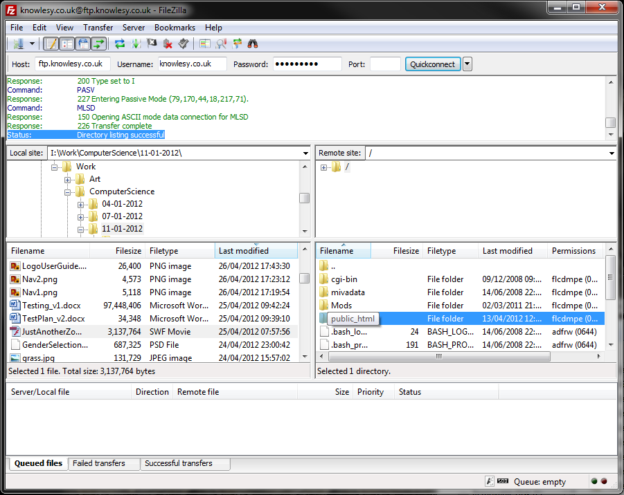

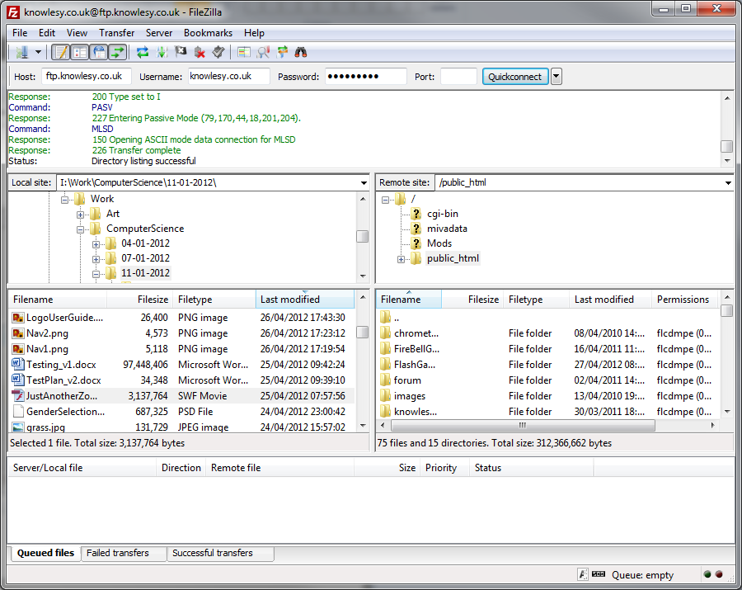
Step 5)
Finally drag and drop JustAnotherZombieGame.swf into the folder called FlashGames. When you drop the file, the box at the bottom of the window will show how much of the file has been transferred. This should only take a couple of seconds to complete.
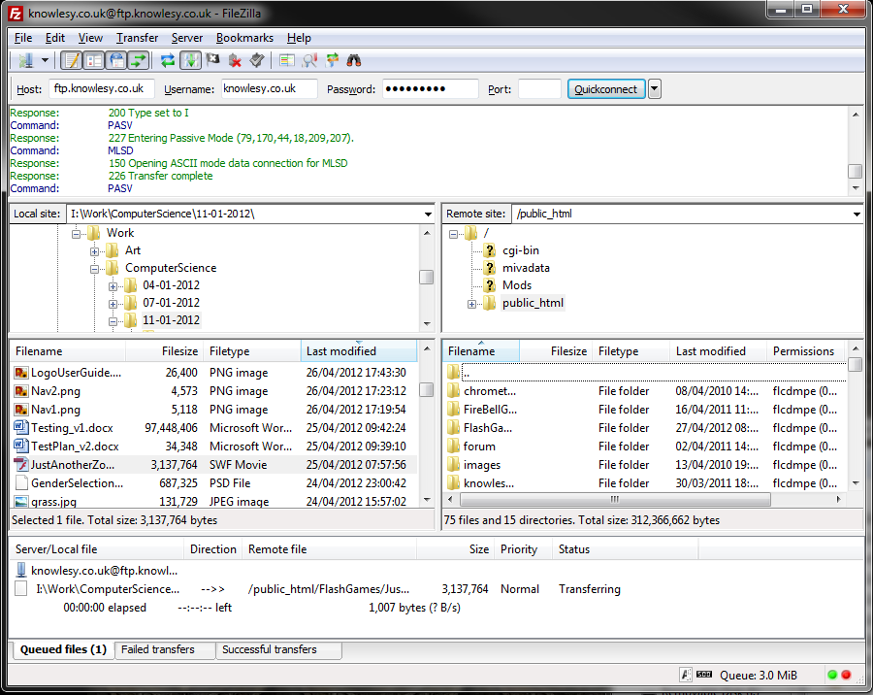
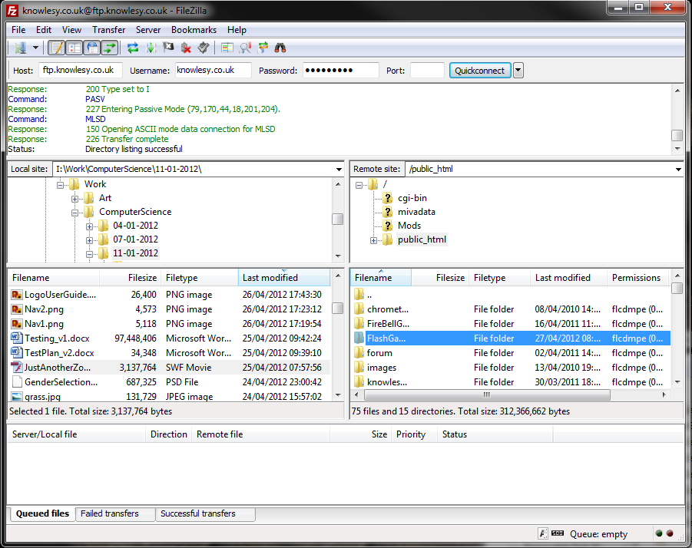
Drop
Drag
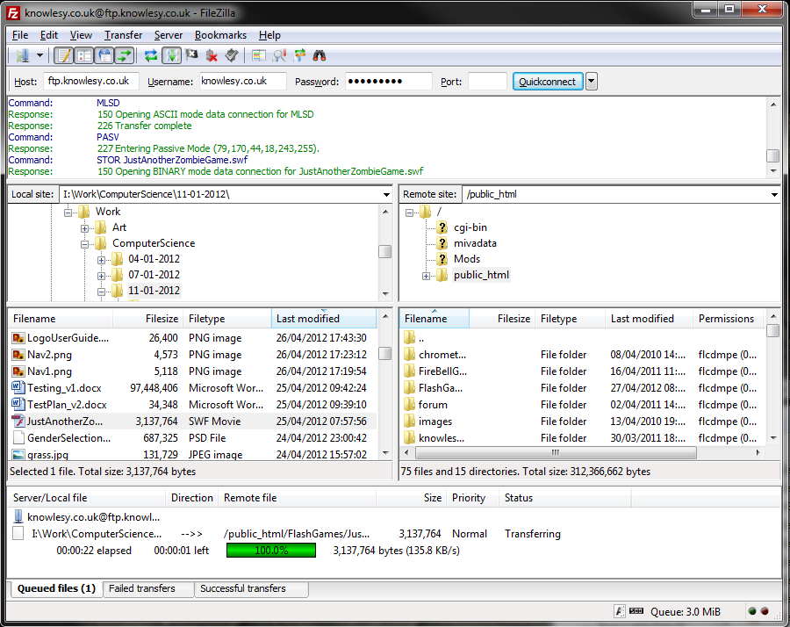

Creating a webpage for the game –

Now we have the game on the server we can place it into webpage. Before we start open your favourite web browser and go to http://Knowlesy.co.uk/wp-admin. The page should like the image bellow.
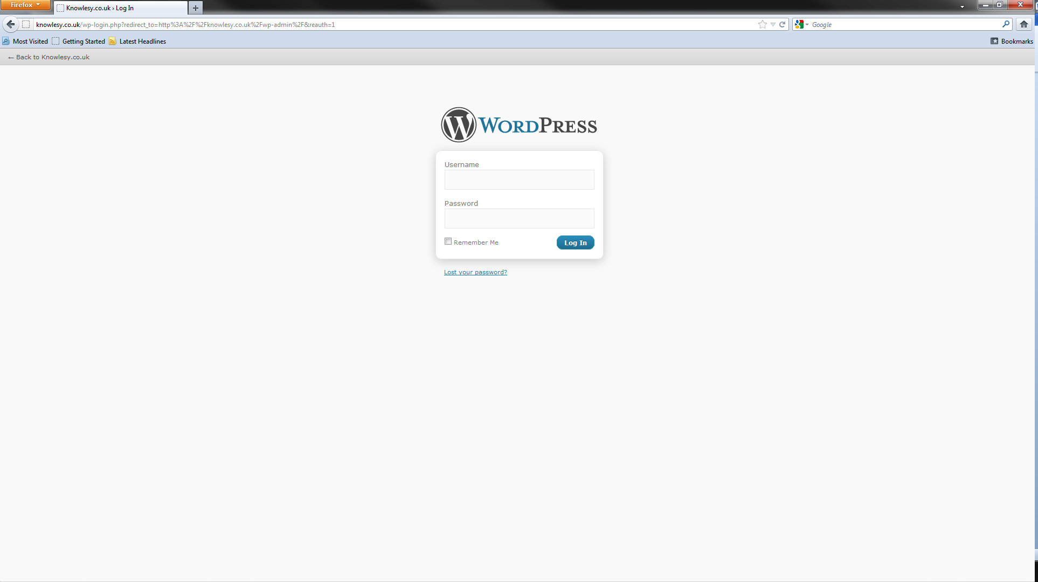
Step 1)
Log in to the web site. You should know your user details.

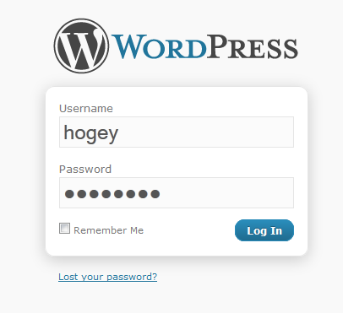

Step 2)
You should now be presented with the WordPress dashboard. You know need to click on Add New under the Page tab on the left hand side.

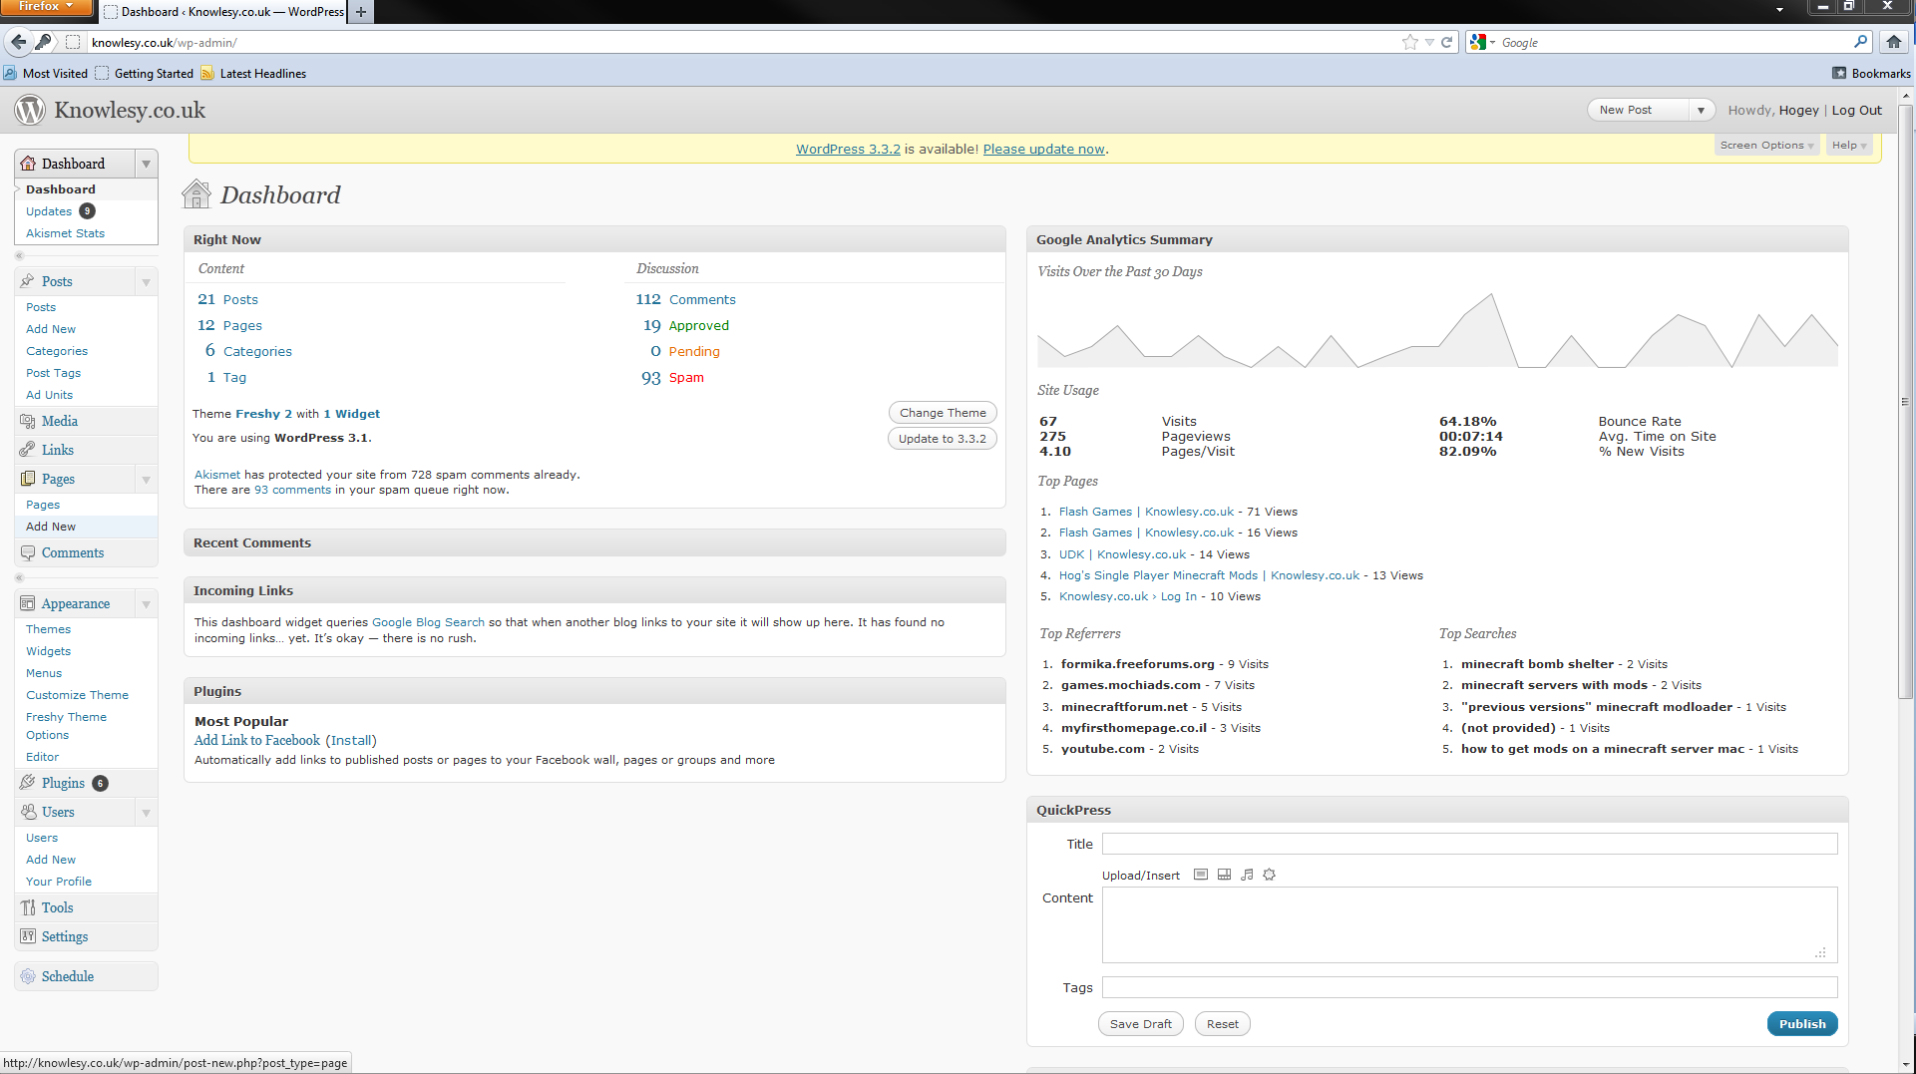
Click Here
Step 3)
Fill in the title as Just Another Zombie Game. Make sure that out of the two tabs, Visual and HTML, that HTML is selected and then copy and paste the code bellow into the box. The image bellow is how it should look.

Code:
<p style="text-align: center;">[kml_flashembed fversion="10.0.0" movie="/FlashGames/JustAnotherZombieGame.swf" targetclass="flashmovie" publishmethod="static" width="550" height="550"]</p>

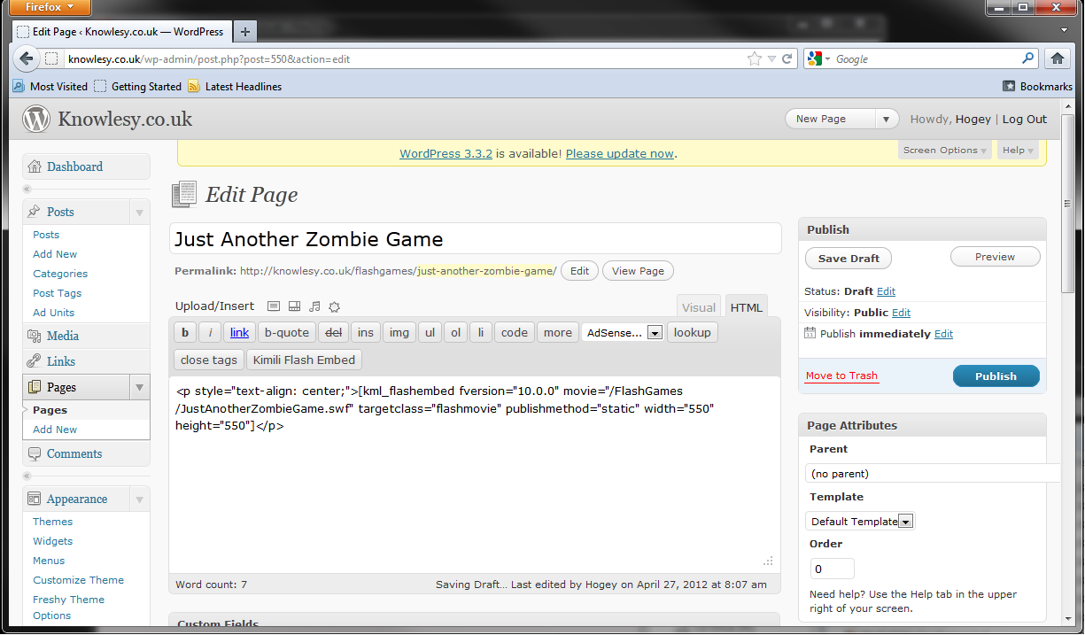
Step 4)
Before we press publish we need to change some little things. Please follow the images bellow.
Change it to jazg to make it easier to reference
Click Here

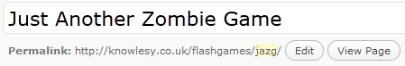

Change the parent to Flash Games so we know which tab it will be under
Click Here

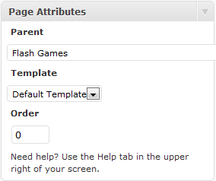
Step 5)
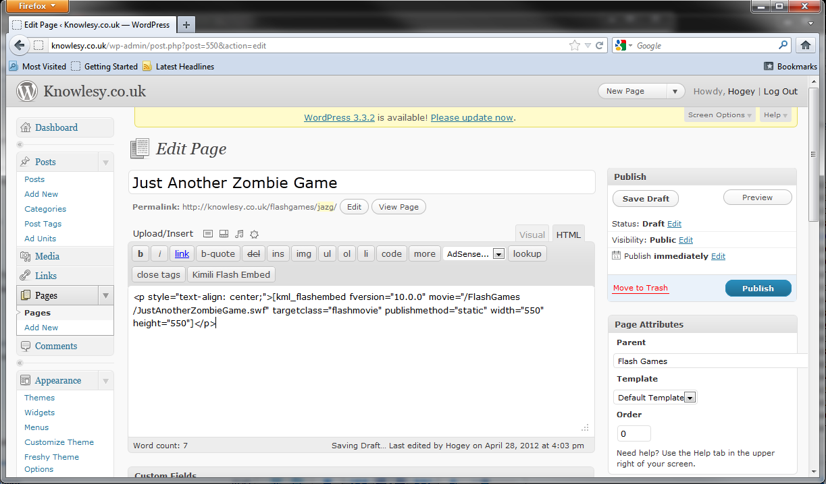
Finally, press the big blue Publish Button and you are done!
Click Here

Player Info

Finding the game –

Before we start you’re going to need to open your favourite web browser. For this example I’m using Internet Explorer.
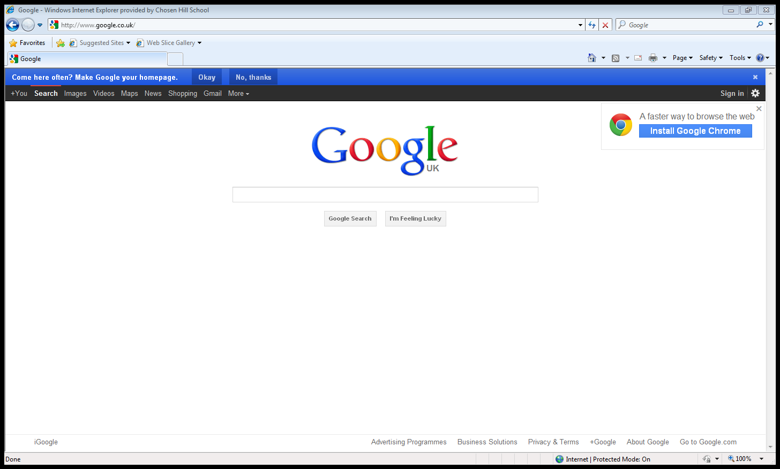

Step 1)
Go to the URL Bar and type in http://knowlesy.co.uk . Then hit enter or press the go button.

Go Button

Step 2)
You should see a web page like bellow come up. You then need to click where it says Flash Games on the sites navigation menu.
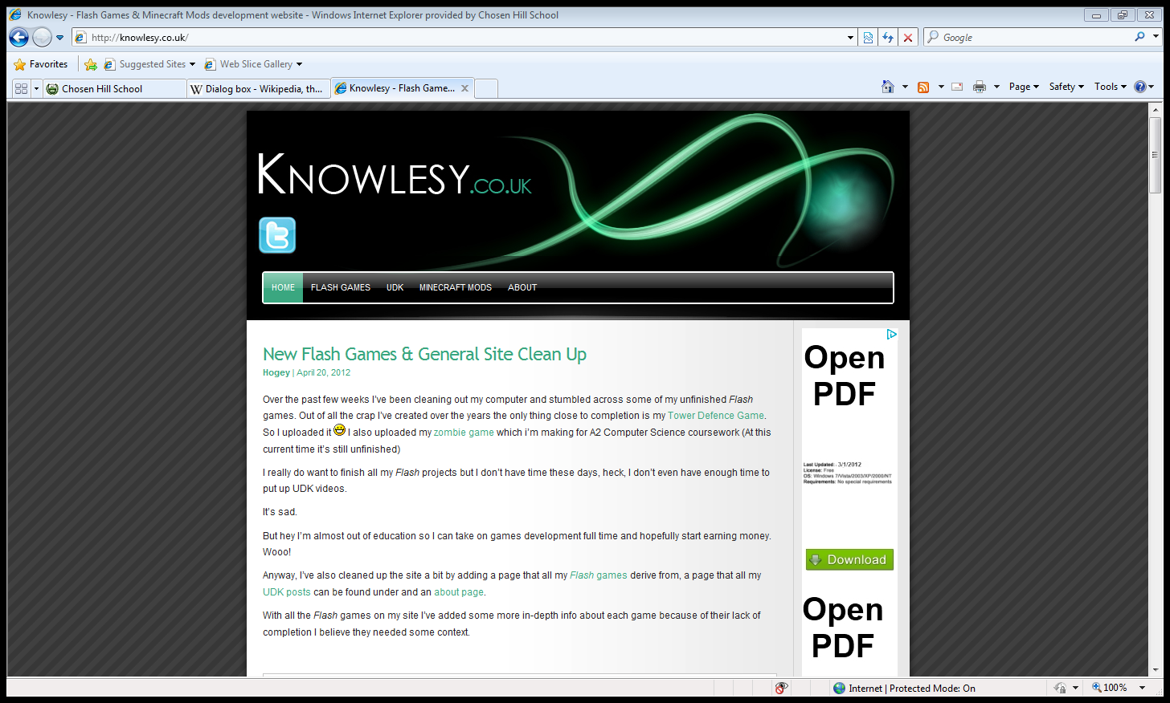
Click Here

Step 3)
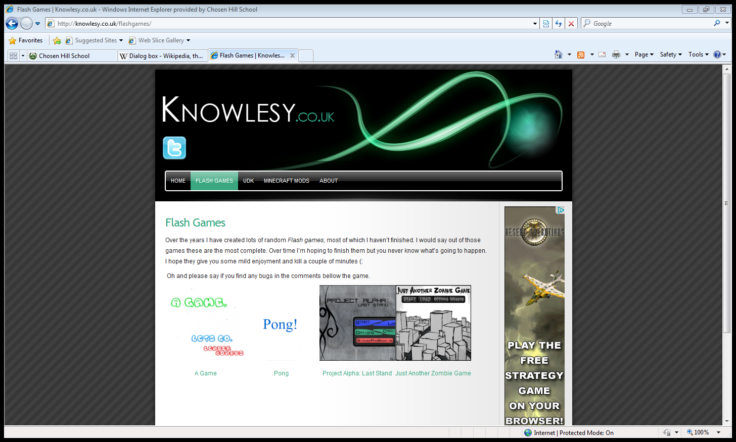
This should take you to another page, again the image bellow should be the same as what you have on your screen. For this step you need to click on either the image, or the text that says Just Another Zombie Game.
Click Here
Step 4)
Congrats! You’ve found the game. Just scroll down a bit and play!
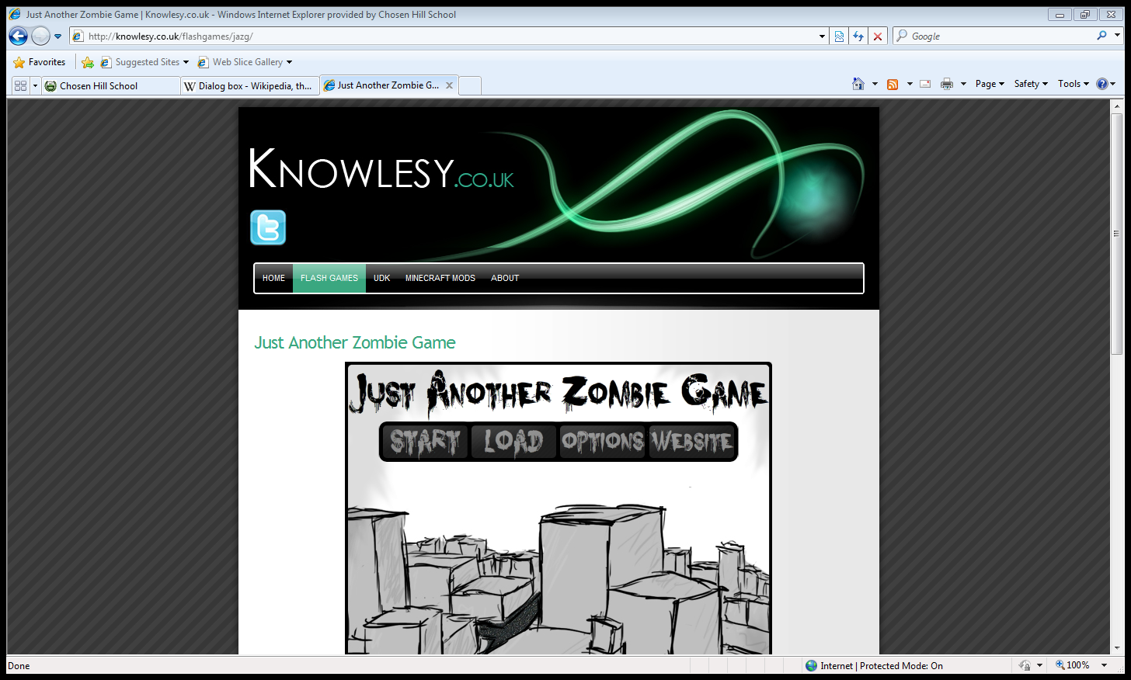

Main Menu –

Starting the Game –

Before we start you need to make sure you have the game open. If you don’t know how to get to the game please look at the previous section, “Finding the Game”.

Step 1)
Press the start button on the main menu. This will play the main menu animation and take you to the start screen.
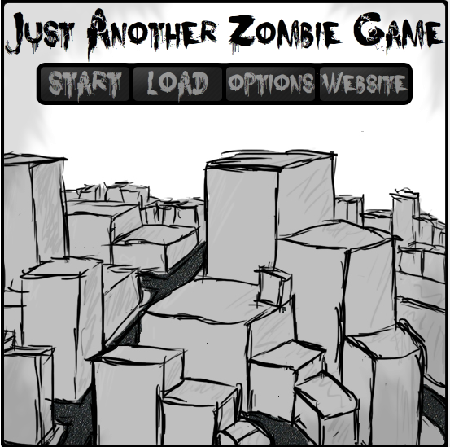
Click Here

Step 2)
You have a choice now you can 1) go through all frames, by pressing anywhere on screen on each frame, and get the background story or 2) Press the skip button and avoid the entire back story. You’ll get to the gender selection screen no matter which route you take.

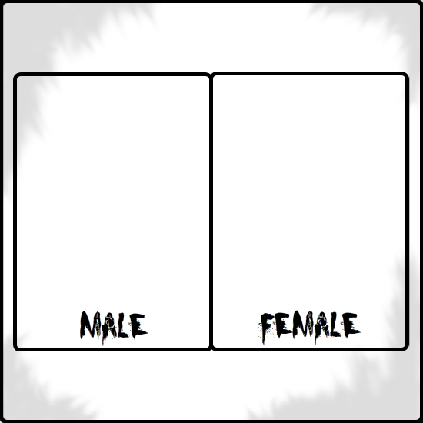

Step 3)
You should now be on to the gender selection screen where you get another choice. You can choose to be a male or a female player. Once you click on one, you will be taken into game and shown how to play. If the in-game instructions don’t give you enough information, please go to the section “In-Game” and look through the sub topics.

Loading a Saved Game –
As this is a demo you cannot load or even save a game. The screen is currently a place holder and will be implemented in the real game.

Changing Options -
Before being able to change any settings you are going to need to get to the options screen. You can get to the options screen from the main menu by pressing the options button.
Click Here

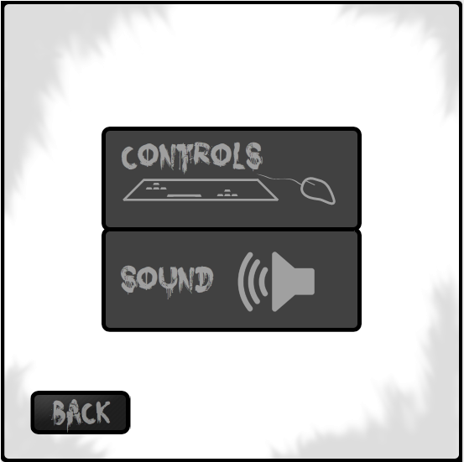

Controls –
From the options screen you need to get to the sound screen before continuing. To get to the controls screen you need to simply press the button that says controls.
Click Here

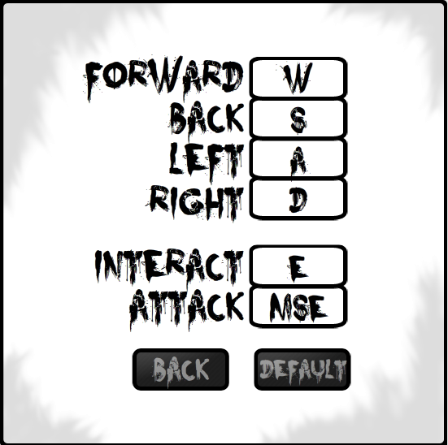
Step 1)
Choose which key you want to change. If you want to change a directional key then follow the steps until step 5 if you want to change the Interact or Attack key skip to step 5.

Directional Keys

Step 2)
Now you have selected a directional key click on the box with the current key in it. For this example I’m going to change the Forward Direction.
Click Here
Current Key for the Forward Direction

Step 3)
Now, if you have selected the wrong box or wish not to change the box you have selected, simply press the box again. If you have the correct box that you want selected, press the key on the key board that you wish to change the directional key to.

I decided I wanted the forward key to be 1 instead of W.

Step 4)
Once you have the keys configured in the way you want, you need to save them. This is done by pressing the back button
Click Here
Step 5)
With the interact and attack keys, when you want to change the key it is similar to the directional keys. To do this first select either key box. For this example I’m going to change the interact key.

Click Here

Step 6)
If you have selected the wrong box or wish not to change the box you have selected, simply click anywhere but not within the current box. If you do click within the current box it will change the key to the MSE which represents the mouse. If you have the correct box that you want selected, press the key on the keyboard that you wish to change the box to.

I decided I wanted the interact key to be space instead of E.

Step 7)
Finally, we need to save the keys. To do this press the back button and you are all done.
Click Here
Sound –
From the options screen you need to get to the sound screen before continuing. To get to the sound screen you need to simply press the button that says sound.
Click Here

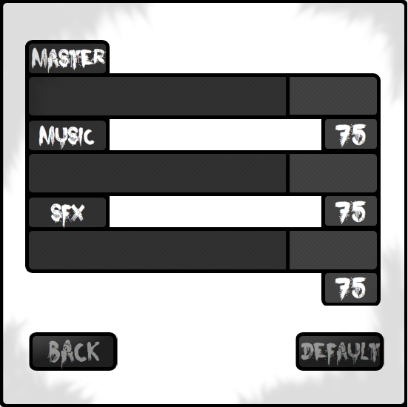
Step 1)
Choose which volume you want to change. It doesn’t matter which you choose this method works the same for each. For this example I’m going change the SFX volume.

Step 2)
Click on the black line with in the bar of the volume you want to change. This will cause the black line to follow the mouse.
Click Here

Step 3)
Move the mouse either left or right within your selected volume bar until the volume % text is at the % you want.

Volume % Text
Move the Mouse Left or Right

Step 4)
Once you have all the volumes at the % you want you must press the back button so the % values get saved
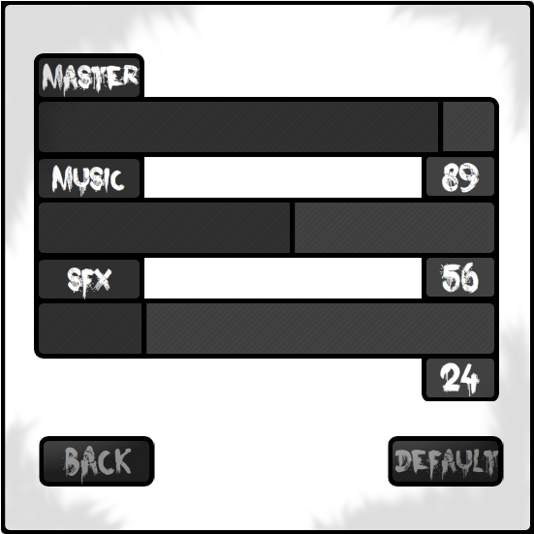
Click Here

Step 5)
You should now be back at the options screen and your changes will be saved. If you wish to change the sound again just repeat step 1 to 4. If you’re unhappy and want the default settings back simply press the default button on the sound screen.

In-Game –
Just Another Zombie Game is currently in a demo state. A lot of content has been missed out and will be put in the full version. Some of this content to be added will be: bigger maps that you are able to explore, missions that you can select at will, day and night cycles, the ability to save the game and more items.

In the demo of Just Another Zombie Game your aim is survive as long as you can. There is plenty of food to help you keep your health up, weapons to fend off zombies and fortifications to keep those pesky zombies out of your house.

Before starting you need to have the game open and on the play screen. To get the game open follow the section “Finding the game” and to get to the play screen follow the “Start the Game” section. Return here once you have a screen similar to the image bellow.
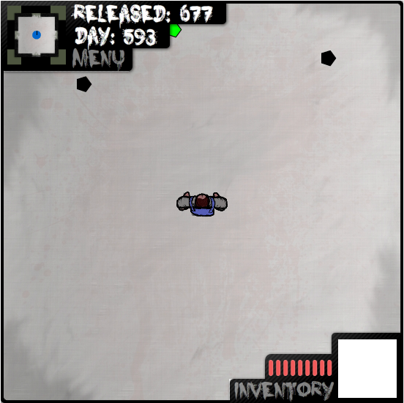
Moving –
Being able to move is a key part of the game and this short tutorial should show you how to do it. Before you start trying to move the player you need to check your controls.
Step 1)
First off, press the menu button on the HUD.
Click Here
Step 2)
Next, press the Controls button on the In-Game Menu.
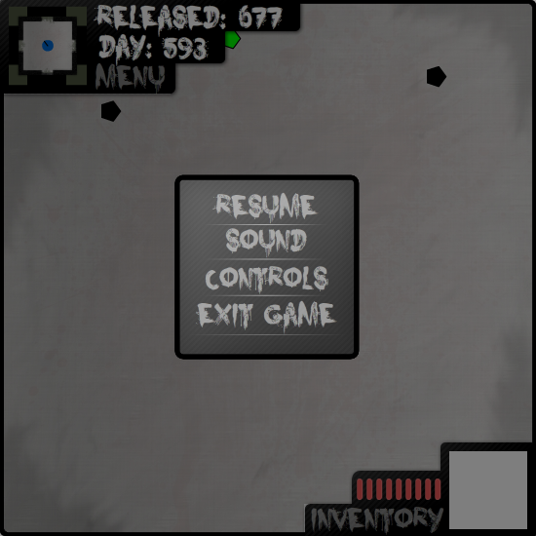
Step 3)
Finally, observe the key you have for moving. As default the keys are W to move forward, S to move backwards, A to move left and D to move right.
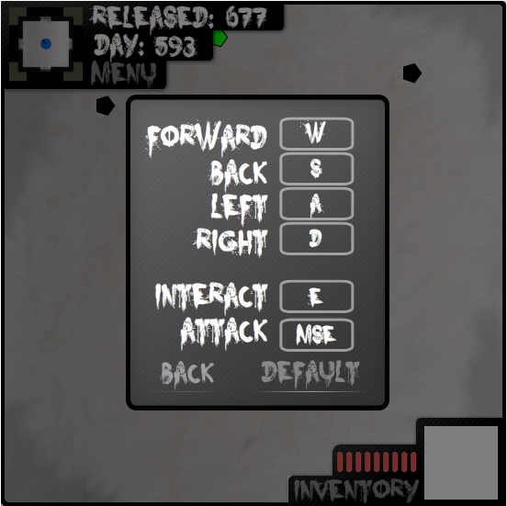
Look at these

Now that you know what your controls are you can start moving in game. Make sure you get back to the game before starting the next group of steps.
Step 1)
Moving forward – You simply just press and hold down the W key or whatever you found out the forward key was in the first group of steps.
Pressing the W key moved the player Forwards

Step 2)
Moving Backwards – You simply just press and hold down the S key or whatever you found out the back key was in the first group of steps.

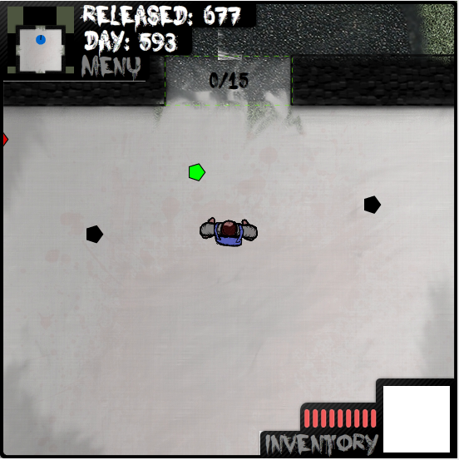
Pressing the S key moved the player Backwards

Step 3)
Moving Left – You simply just press and hold down the A key or whatever you found out the left key was in the first group of steps.

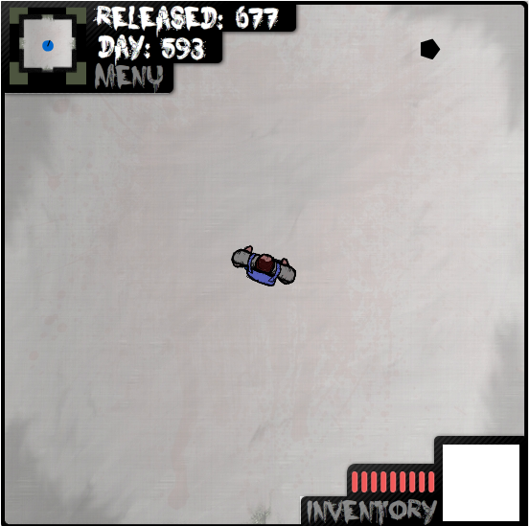
Pressing the A key moved the player Left

Step 4)
Moving Right – You simply just press and hold down the D key or whatever you found out the right key was in the first group of steps.

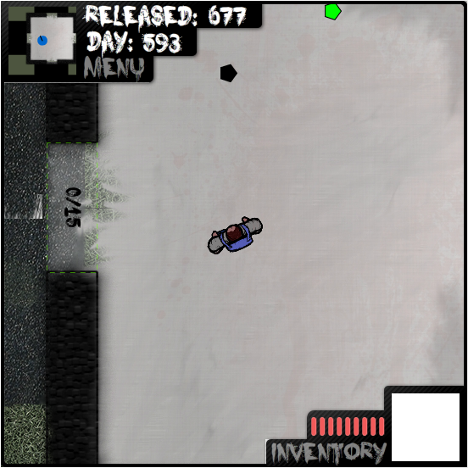
Pressing the D key moved the player Right

Health –
Keeping an eye on your health is always a good idea. Your health bar is located at the bottom right screen
When you take damage the screen flashes red and one of your health lines goes out. Once all 9 health lines go out, the game will end. To regain health lines you must collect and eat food. To learn more about food please look at the “Foods” sub section of “Using Items”
Picking up Items –
Currently items don’t have skins. You can tell which type of item and item is which by the colour of the pentagon.

Black is a fortification.
Green is food.
Red is a weapon.

To pick an item you simply have to approach it. When you get within a certain range a message will appear say “Press [Interact key] to pick up”. It’s quite simple!
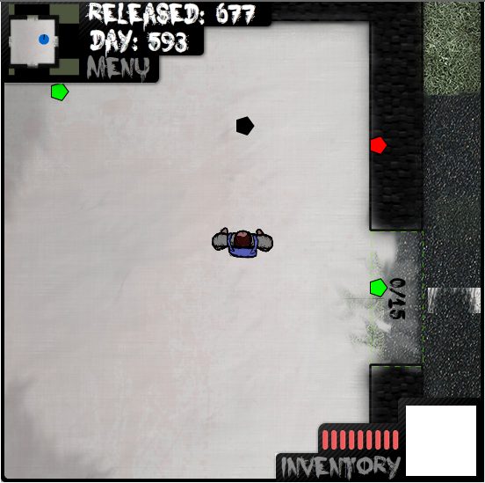

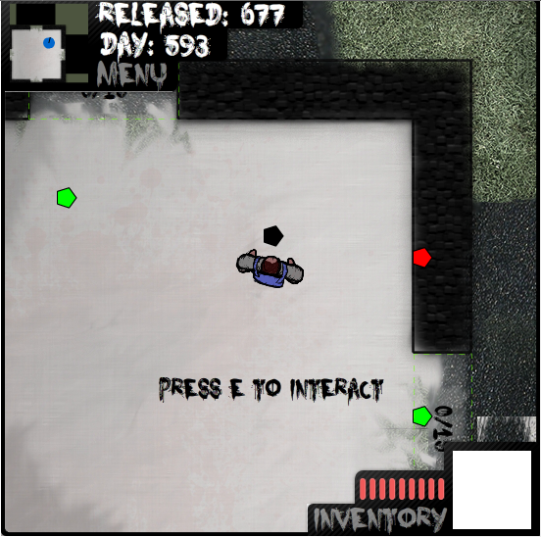

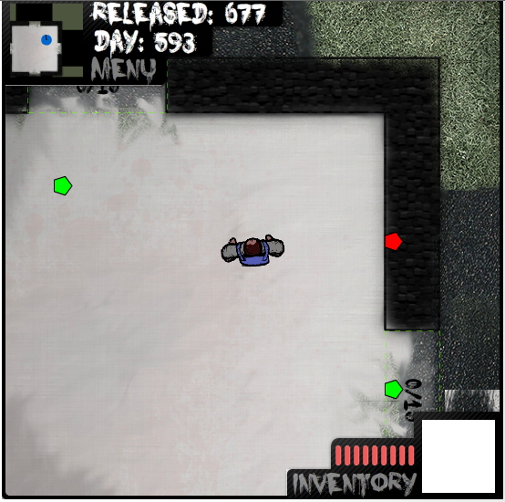

Using Items –
Now you have pick up an item you need to know how to equip it.

Step 1)
You need to open your inventory. You do this by pressing the Inventory button on the HUD.
Click Here

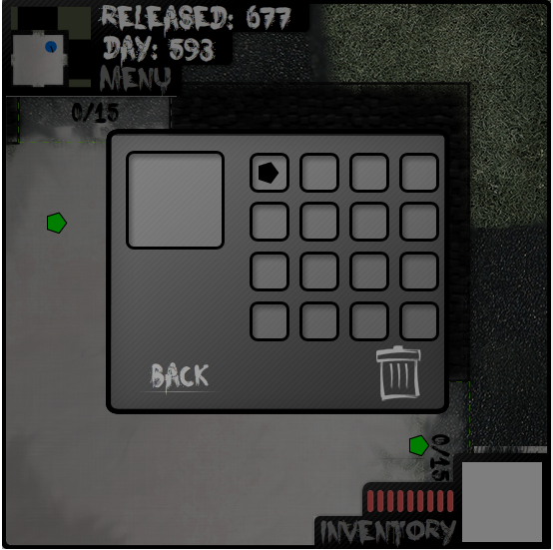
Step 2)
Press and hold on the item you want to equip the player with. Seeing as I’ve only picked up one item I’ll be using that. Then drag it over to the big square on the left hand side and then stop holding the mouse.

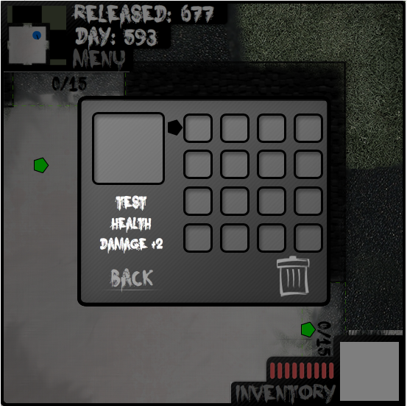

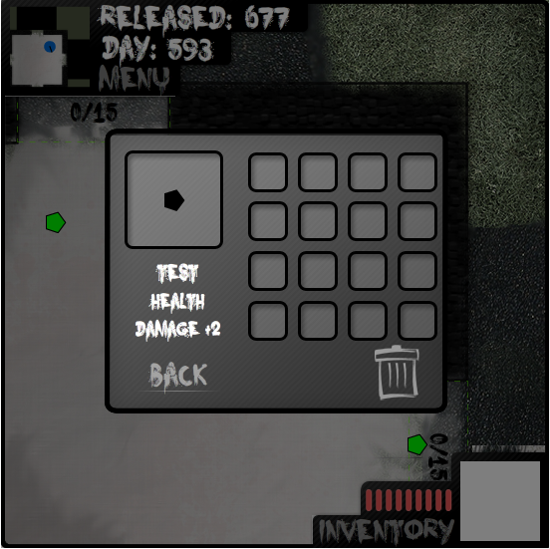
Now you have an item equipped you want to know how to use it. Each of the follow sections will show you how to work the different item types.

Weapons –
To use a weapon you simply equip it and then go out of the house, find a zombie and hit the attack key. Zombies have a health of 3 so higher tiers of weapons can kill them in one hit.
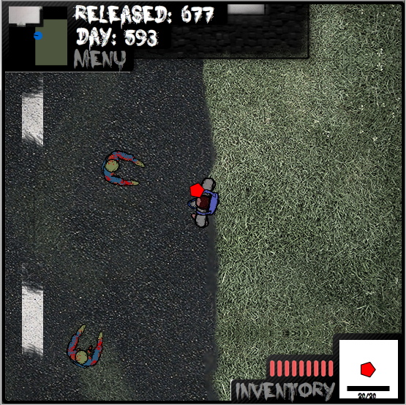

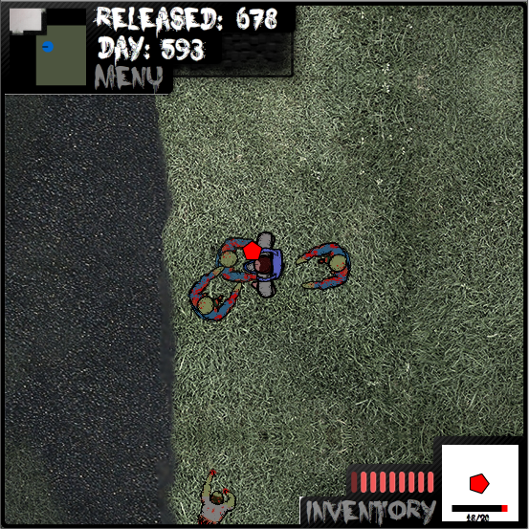
The current Zombies have death animations, so they simply stop moving and fade out when you kill them.

Foods –
When you take damage from a zombie you need eat food to regain health. To do this you simply equip yourself a food (the green pentagon) and press the attack key once you have come out of the inventory.
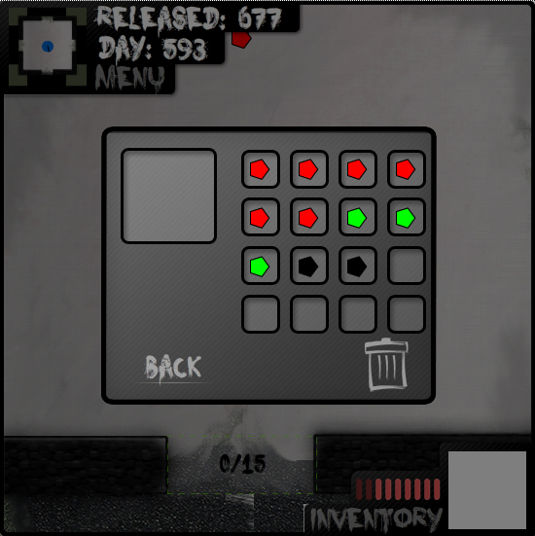

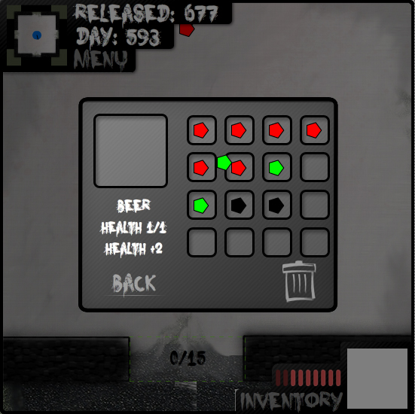

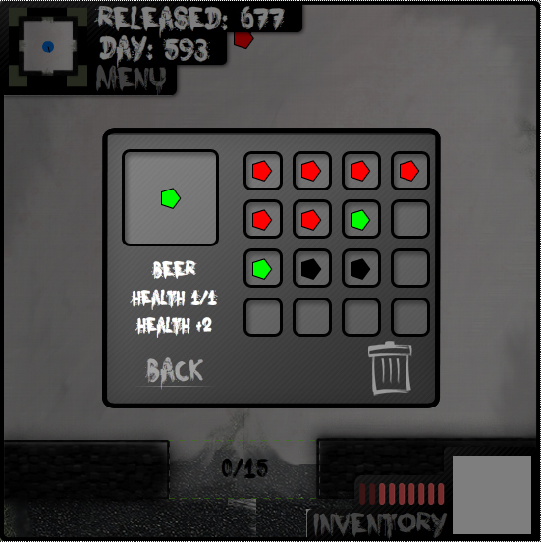
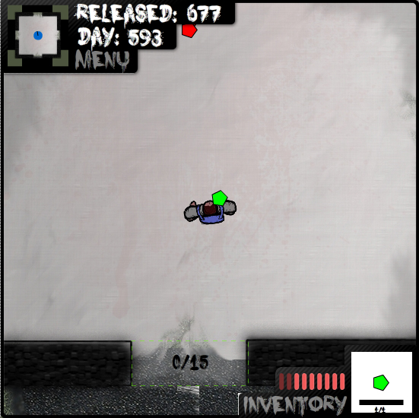

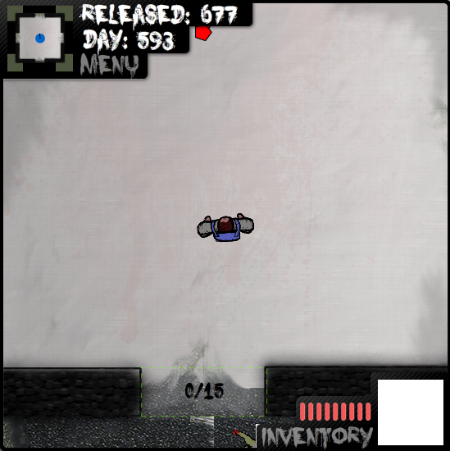

Fortifications –
When the zombies come in full force you will want to keep them out of your house. You do this by building up fortifications. Building fortifications is easy, all you need to do is pick up a black pentagon, equip it, and walk up to a fortification slot. Then press the attack key and this will add heath to the fortification slot.

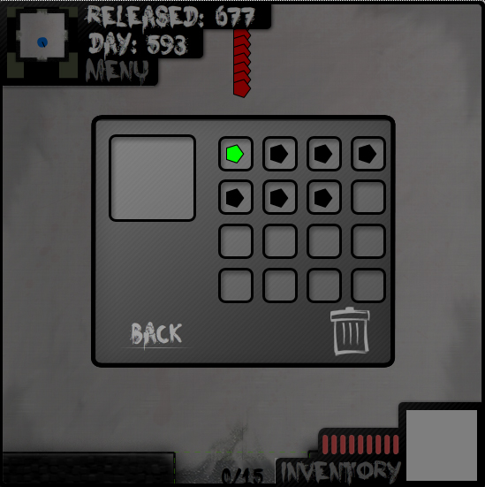

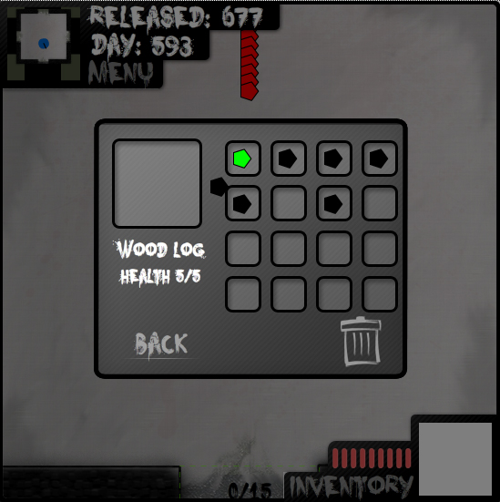

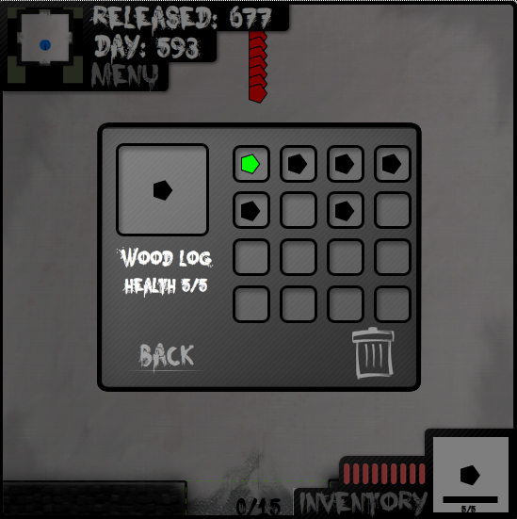

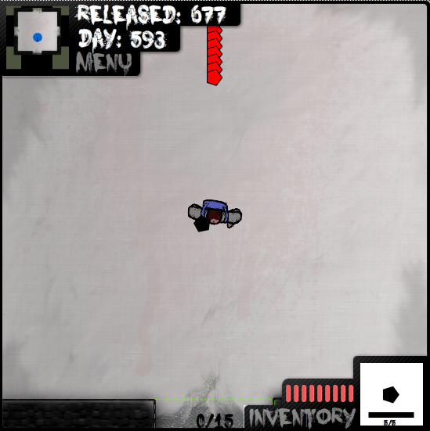

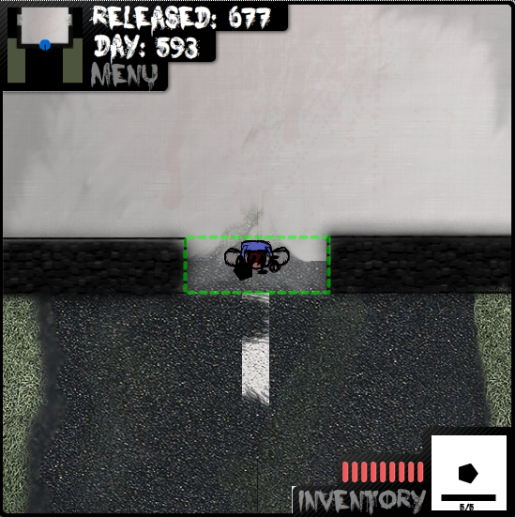

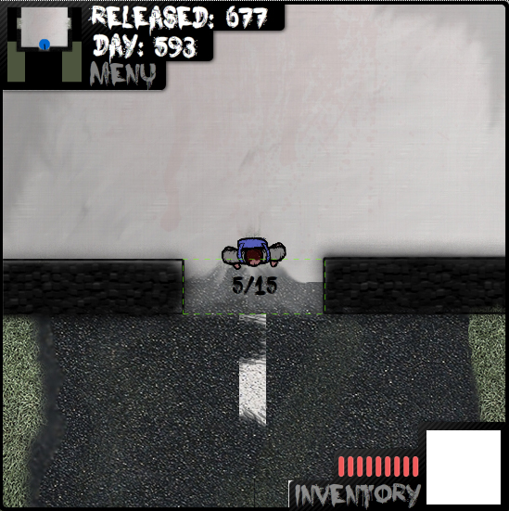
Glossary

Dialog box –
This is just small window that comes up asking for some sort of input
Directional key –
These are the keys in the control menu that dictate which direction you will go when you press them
Email client –
This is program that lets you manage your emails
File directory –
A list of files that you are able to navigate through
FileZilla –
This is an open source program used to upload file to a server
FTP –
File Transfer Protocol – used to upload data to the server
Health lines –
These are the singles red bars that make up the health bar
Host –
In this context it is the address of the FTP for the server
HUD –
Heads Up Display
Internet Explorer –
A web browser that comes as standard with every copy of windows
Mozilla Firefox –
A free and open source web browser
Navigation menu –
The bar on a webpage that allows you to reach other pages on the website. This bar is usually consistent throughout all the webpages on the website
Server –
An external location that stores data and can be reached using web addresses
SFX –
Abbreviation for sound effects
URL Bar –
The bar at the top of your web browser that you insert web address to reach websites
Volume % text –
Text that shows what percentage the volume bar is at currently
Web browser –
A program that allows you to view webpage
WordPress -
A free and open source blogging tool

