Objectives
Using my user requirements I have produced I have created a list of criteria that I must achieve to please the administrators of knowlesy.co.uk.

The game must be able to work with flash player 10 and greater. This then outlines that the game must work with browsers that support flash.

I can complete this by selecting the publish setting in flash. This then allows me to customize pretty much everything about the swf file.

The game must be a top down sandbox game.

This will be done when designing the screens with the use of a scrollable map and other techniques.

The setting of the game will be in a suburb and sticking with the idea of sand box the player will be able to travel to collect resources and complete tasks

This again will be achieved in the design.

The player of the game will be able to choose the gender of the main character

This will be done just after the introduction of the game has finished and before the user is able to play the game. This will change the users in game sprite based on which gender they have chosen.

There should be AI player within the game that impact the story line depending on how the player interacts with them

Seeing as this will be a demo that can be easily modified there will only be one AI player in the game. This player will be able to avoid walls, attach enemies and follow the player.

There should be a variety of zombies, not only human ones but animals as well

This will be a simple change of sprite and stats/data values to represent different enemies. They will most likely use the same code.

The game should pick up intensity as it goes along.

This is another bit that’ll be handled in the design. As this will only be a demo the game’s intensity wouldn’t change too much.

To regain health the player must eat food they have found.
There should be items/weapon scattered around for the player to go and find

When designing the map; food, weapons and other items will be placed for the player to find and collected.

The game will use a combination of mouse and keyboard to be played

When creating the game’s input detection, it will mainly be looking out for mouse and keyboard input.

Game Intro Storyboards

These screens will play out once the player chooses to press the start button on the main menu.
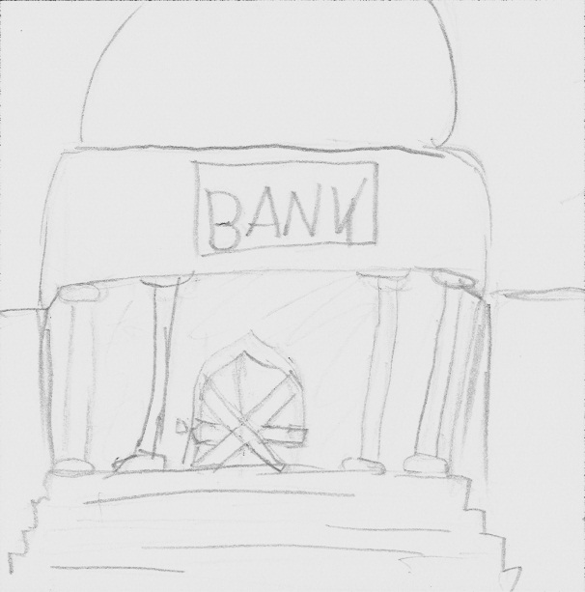 | 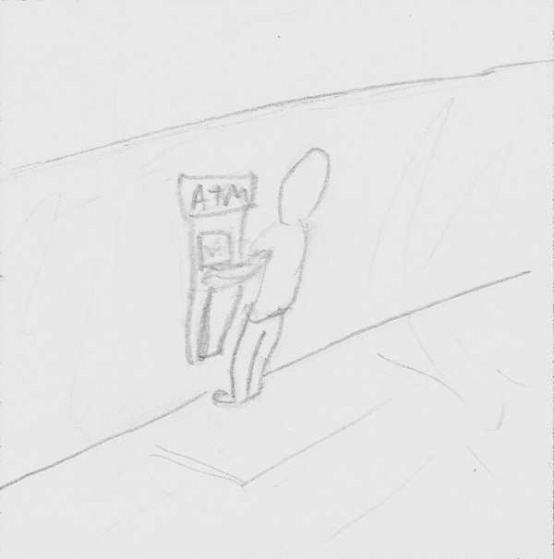 | 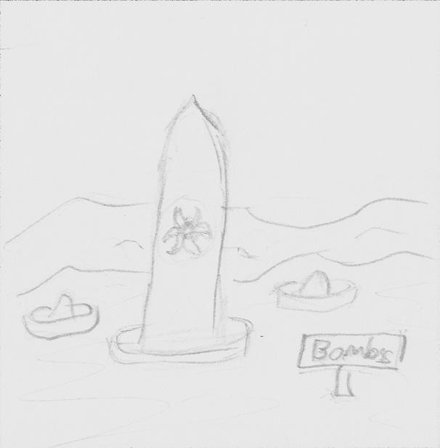 | 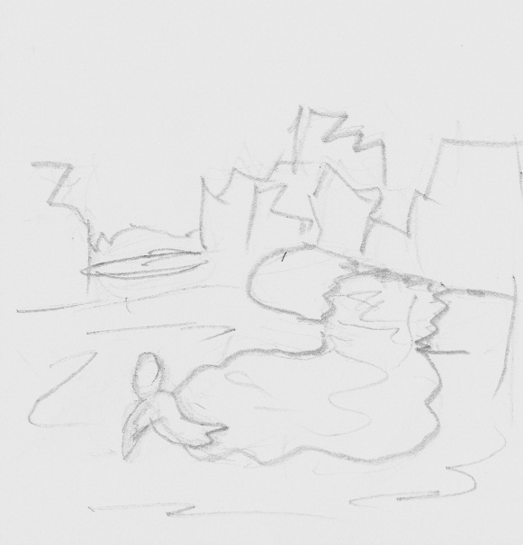
In 2013 the true results of greedy Bankers and dodgy commodity dealers has brought the world’s economy to its knees. Countries around the world are now so short of money reserves that they are unable to pay workers. | Taxes are not being collected banks have shut and there is no cash in cash machines. Countries are desperate to reclaim what they have lost by any means necessary. | Tempers rose, arguments spilled over to scuffles between politicians and so came war. | Thousands of innocent civilians perished as a result. Those who weren’t so lucky mutated from the high doses of radiation causing them to become savage and irrational; attacking and eating every living creature. Survivors called them ‘zombies’ because of their lifelessness and hunger for living flesh. They roam aimlessly around the streets all day but seem to gather in great hordes in the late hours of the evening.

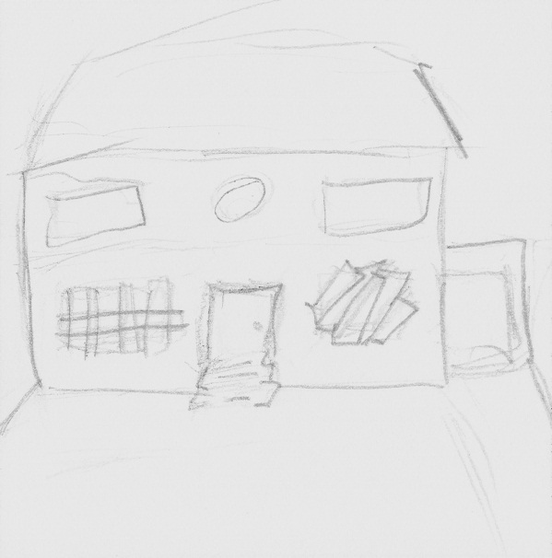 | 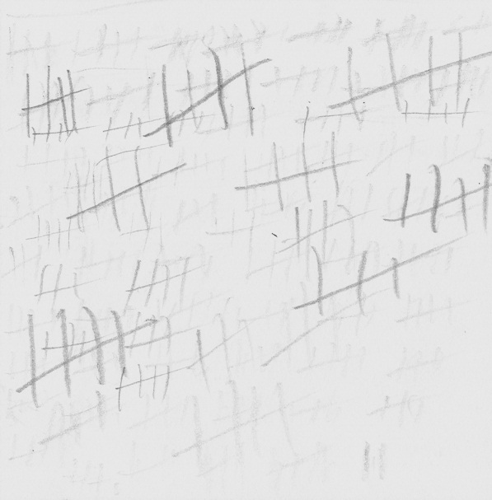 | 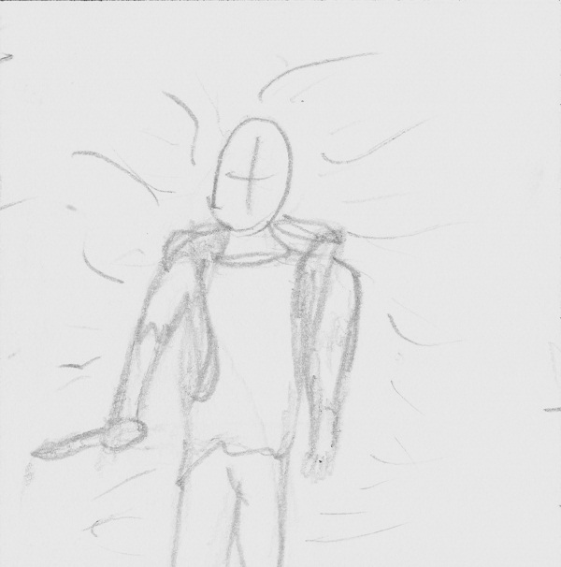 | 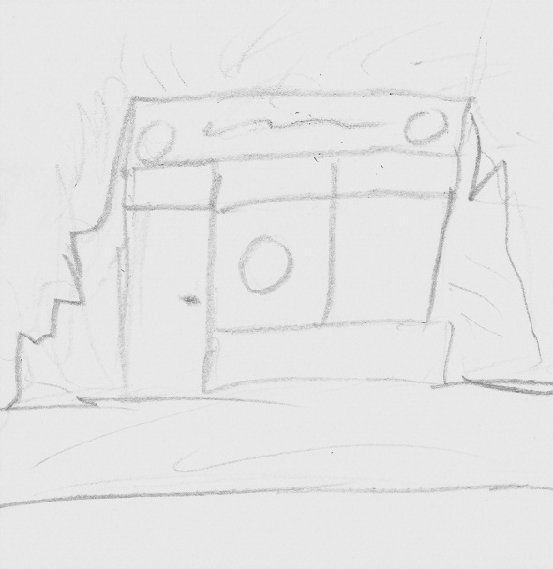
Trying to live in this chaos is hard but I’ve been doing it for the last 19 months. Its kill or be killed. I’ve seen a lot of lost souls turned to flesh eating monsters | I keep a count of how many I have had to release from their suffering. I mark them on my wall as a show of respect and today I added another bringing my total to 677. Months have gone by without seeing another survivor, sometimes I believe I’m the only one left. | But at the time of loneliness another stranded survivor always seems to appear, helping me regain my faith and survive. | We talk briefly when paths cross and they all seem to speak of what I desire, Burger Star, with such delight and enthusiasm; making me crave what I thought had been once lost forever. They speak of it being untouched, uninfected and open all hours.  I must find it.

Demo Overview

For the demo I have decided that to be able to meet my objectives, in the allotted time for this project, I am going to have to simplify the game.

The game will start once the user has pressed the start button on the main menu. This will then lead to start screen which explains the plot behind the game. Then the use is given the choice of gender for the player.

After selecting the gender the player will start in a room with four entrances and fortification areas. A help screen will come up explaining the HUD to the user. It’ll then demonstrate how to kill enemies, gain health and add to fortifications. Once this is complete, the player will be able to roam around the map.

As the player collects items from around the map the number of enemies spawning will increase, adding to the difficulty of the game. In one of the corners of the map an AI player will be placed, the user will be able to interact with it choosing whether or not to take him with them.

The game will end when the player runs out of health. This will bring up a screen saying thank you for playing.

Game Characters

All characters will be made up of two images placed on top of each other. The bottom layer (legs) rotate depending on what the direction the characters is moving the player. The top layer (body) rotates to face towards whatever the character is trying to attack or in the players case, the mouse.

Player
[Image]
Animations: Idle, Running, Attacking, Dead
The player is what the user will control using the keyboard and mouse.

AI Player
[Image]
Animations: Idle, Running, Attacking, Dead
The AI player will follow the player attacking any enemies in range of itself or the player.

Zombies
There are three different types of zombies but all has the same basic traits:
- They all deal the same amount of damage
- They all have the same health
- They are able to attack both the player and fortifications
- They have three animation states of moving, attacking and dead

Image: | Type: | Info:
[Image] | Dragger | This Zombie is the slowest of the three by the fact that it drags its own body around because it has no legs; this causes the zombie to leave a blood trail. It also has the furthest range
[Image] | Walker | This zombie has the average speed and range. He stumbles around.
[Image] | Dog | The dog is the fastest of the three but has the shortest range. They spawn in packs of three.

Game Items

There are 3 types of Items that the player can have. These are:
- Fortifications
- Foods
- Weapons
All items can be found around the map. All items may need to be rebalanced to make the game fair.

These items are used by pressing the attack/use key. When an item is used, the attack animation for the player is run and health is taken from the item.

Fortifications

These items are used to fortify the safe house. A dedicated area is placed on the map where the user can place these items. This is highlighted when the user has a fortification item as their currently selected item. The user is able to walk through them (when placed) but enemies will attach them and are not able to pass through them.

[Image]

When this type of item is used on a fortification area its current health gets added to the total health of the fortification area. When use without a fortification area nothing happens.
[Image] | Name: | Health: | Effect:
 | Wood Log | 5 | Adds to fortification
[Image] | Name: | Health: | Effect:
 | Sofa | 15 | Adds to fortification
[Image] | Name: | Health: | Effect:
 | Wardrobe | 10 | Adds to fortification
[Image] | Name: | Health: | Effect:
 | Table | 7 | Adds to fortification
[Image] | Name: | Health: | Effect:
 | Chair | 7 | Adds to fortification
[Image] | Name: | Health: | Effect:
 | Computer | 10 | Adds to fortification

Foods
These items regain health to the player. When the item is used the effect is run and the item loses 1 health.
[Image] | Name: | Health: | Effect:
 | Tinned Food | 1 | Health +1
[Image] | Name: | Health: | Effect:
 | Beer | 1 | Health +2
[Image] | Name: | Health: | Effect:
 | Bacon | 1 | Health +3

Weapons
These items are used to inflict damage to enemies. When used on an enemy the items effect is run and the item loses 1 health.
[Image] | Name: | Health: | Effect:
 | Spade | 20 | Damage +2
[Image] | Name: | Health: | Effect:
 | Cricket Bat | 20 | Damage +2
[Image] | Name: | Health: | Effect:
 | Brick | 10 | Damage +1
[Image] | Name: | Health: | Effect:
 | Wrench | 10 | Damage +1
[Image] | Name: | Health: | Effect:
 | Knife | 14 | Damage +1
[Image] | Name: | Health: | Effect:
 | Chain Saw | 20 | Damage +3
[Image] | Name: | Health: | Effect:
 | 2x4 | 20 | Damage +2
[Image] | Name: | Health: | Effect:
 | Saucepan | 10 | Damage +1
[Image] | Name: | Health: | Effect:
 | Scythe | 20 | Damage +2
[Image] | Name: | Health: | Effect:
 | Hammer | 20 | Damage +1

Game Screens

Before fully designing my game screens I have emailed that admin at knowlesy.co.uk, with the image bellow, and asked them which design is there favourite.
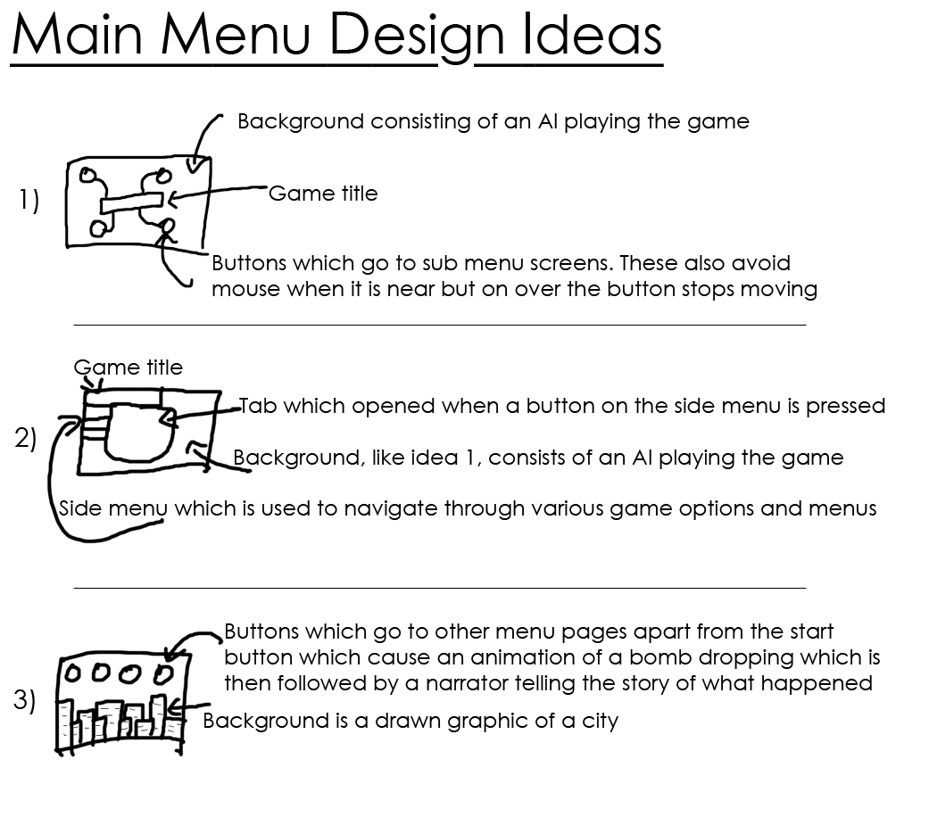

Once I was told to go with the third idea I produced 5 sample screens and sent them over to admins asking for their opinion.
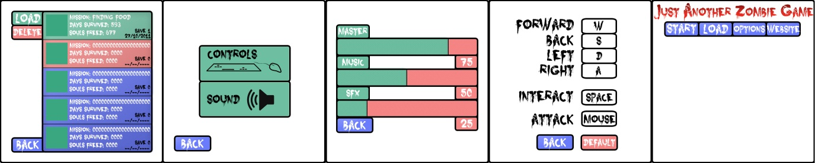

Seeing as the administrators of Knowlesy.co.uk thought my designs were too brightly coloured for a zombie game I re-did them.

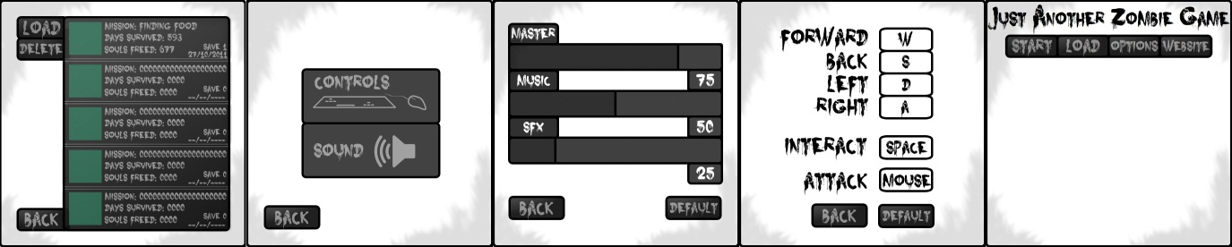

Note – all buttons have mouse over states to show the user that they can interact with that button. These states usually consist of the colour of the text becoming brighter.

Main Menu

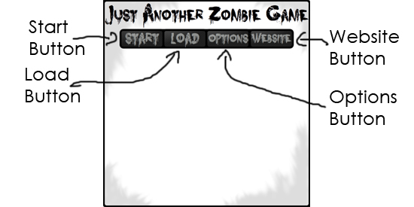

[Currently missing background graphic] This is the main screen of the game. The user is able to navigate to all other screens from here and all back buttons on child screens will return to this screen.
Start – On press this goes to Start Screen
Load – On press this goes to Load Screen
Options – On press this goes to Options Screen
Website – On press this opens a web browser to view Knowlesy.co.uk

Start Screen [Child of Main Menu]

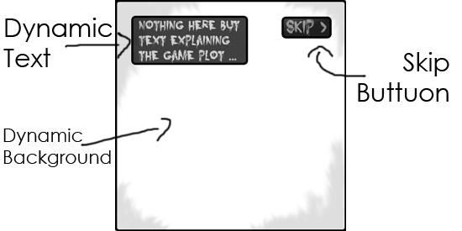

This screen is for explaining the storyline to the user. The screen is dynamic with different background images relating to current text on screen.

Skip – This takes the user straight to the Gender Selection Screen
Dynamic Text – Text within here changes to explain the story to the user

Gander Selection Screen

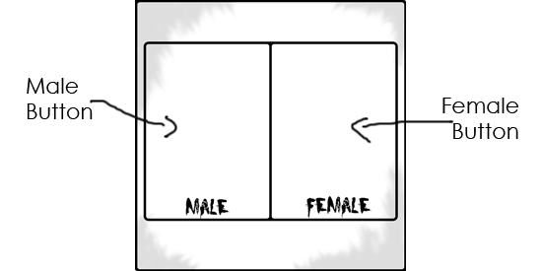

[Currently missing graphics] This screen appears after the Start Screen has been through all of the storyline or the skip button was pressed. The player is able to choose which gender they wish to be. At the current time not benefits come from being either gender.

Male – Sets the user’s character in the game to a male.
Female – Sets the user’s character in the game to a female.

Load Screen [Child of Main Menu]

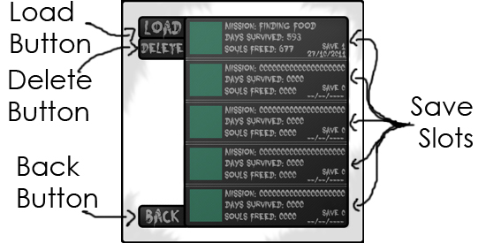

All though you cannot save the demo, I am adding in a save screen for the admins to use when finishing off the game. This screen is for allowing the user to load or delete a previously saved game.

Save Slot – On Press the image becomes lighter. This will also change the image on the delete and load buttons, showing the user that they can now use these buttons
Load – Only once a save slot has been selected can the user press this button which will then take them to the User Interface Screen
Delete – Again, a save slot must be selected before the user can click on it. This button removes the save slot object off screen, deletes the saved data and pulls all the save slots below it up to fill the space.
Back – This returns the user to the Main Menu Screen

Options Screen [Child of Main Menu]

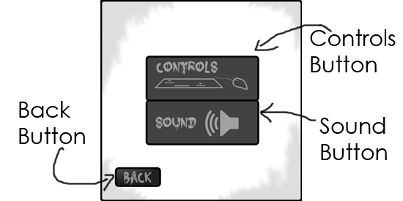

This screen allows the user to choose whether they want to alter the volume of game music/Sounds or change the game controls. Both controls and sound buttons have roll over effects.

Controls – On pressed clear all objects off screen and bring visible Controls Screen
Sound – On pressed clear all objects off screen and bring visible Sound Screen
Back – This returns the user to the Main Menu Screen

Controls Screen [Child of Options]

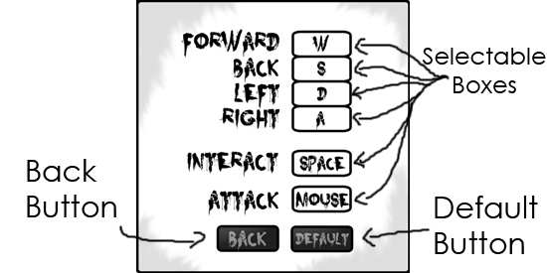

This screen gives the user the ability to alter the game controls. The boxes next to text have letters in them that represent the current key to do the specific action. These boxes can be selected, and then if a key is pressed the letter will change to the key that was pressed.

Default – On pressed returns all keys to their original keys
Back – On pressed clear all objects and bring back Options Screen Objects

Sound Screen [Child of Options]

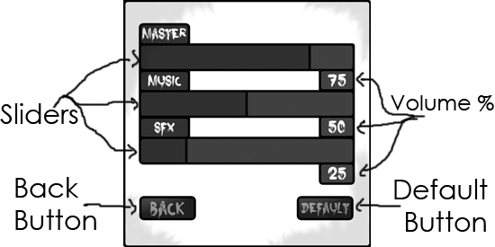
This screen allows the user to adjust the volume for all game sounds, sound effects and music. Each title has a slider and number which represent the current percentage of volume for that title. The slider can be moved to change the percentage of volume.

Default – On pressed returns all volumes to their original percentage
Back – On pressed clear all objects and bring back Options Screen Objects

HUD

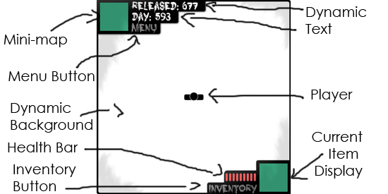

This is the screen that the user will play through. Input will control the player/background. There are two buttons, a mini-map, current item display, health bar and dynamic text on screen. Dynamic text is used to display both the day and the number of kills the user has within the game.

Menu – This pause the game and displays the Options Menu
Inventory – This pause the game and displays the Inventory

Options Menu [Child of User Interface]

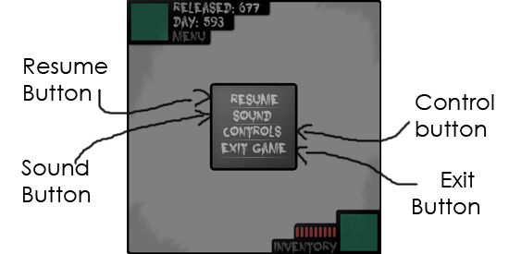

This screen gives the user the ability to change game settings and exit the game. When up it disables the use of the UI Screen bellow it.

Sound – Resizes the current screen and displays Sound Menu
Controls – Resizes the current screen and displays Control Menu
Exit – Brings up a screen to ask the user if they want to quit which then allows them to come back to the Options Menu or returns To the Main Menu Screen
Back – Takes the user back to the game (UI Screen) and un-pauses it as well

Sound Menu [Child of Options Menu]

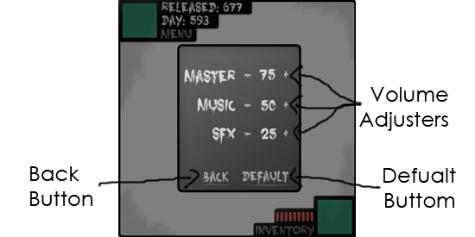

Has exactly the same functionality as the Sound Screen but is simplified. Instead of sliders the user must use plus and minus buttons to alter the volume.

Default – Sets volume back to default
Back – Returns the user to the Options Menu

Controls Menu [Child of Options Menu]

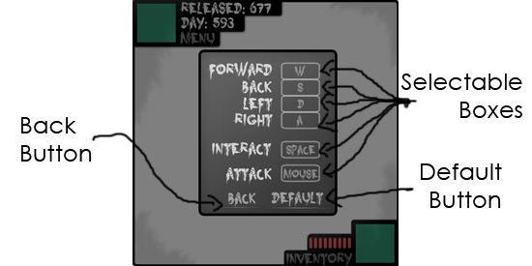

Has exactly the same functionality as the Controls Screen but is within a smaller window so they player can change key whilst playing

Default – Sets keys back to default
Back – Returns the user to the Options Menu
Inventory [Child of User Interface]

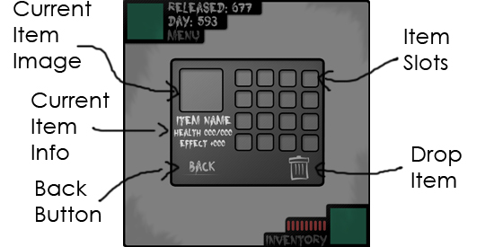

This screen allows the user to manage their current in-game items. The user is able to drop unwanted items and equip items as well. Items are equipped and move around slots by dragging and dropping. This screen also pauses the game.

Drop Item - Drops the currently selected item on the ground
Back - Return the user back to the game.

Help
To help the user I have design multiple screen captions that show up when the player starts the game. They can be skipped if the user has already played the game. On each screen the user has a next button to move onto the next screen. Seeing as there is so many of them, to save paper I have shrunk them.
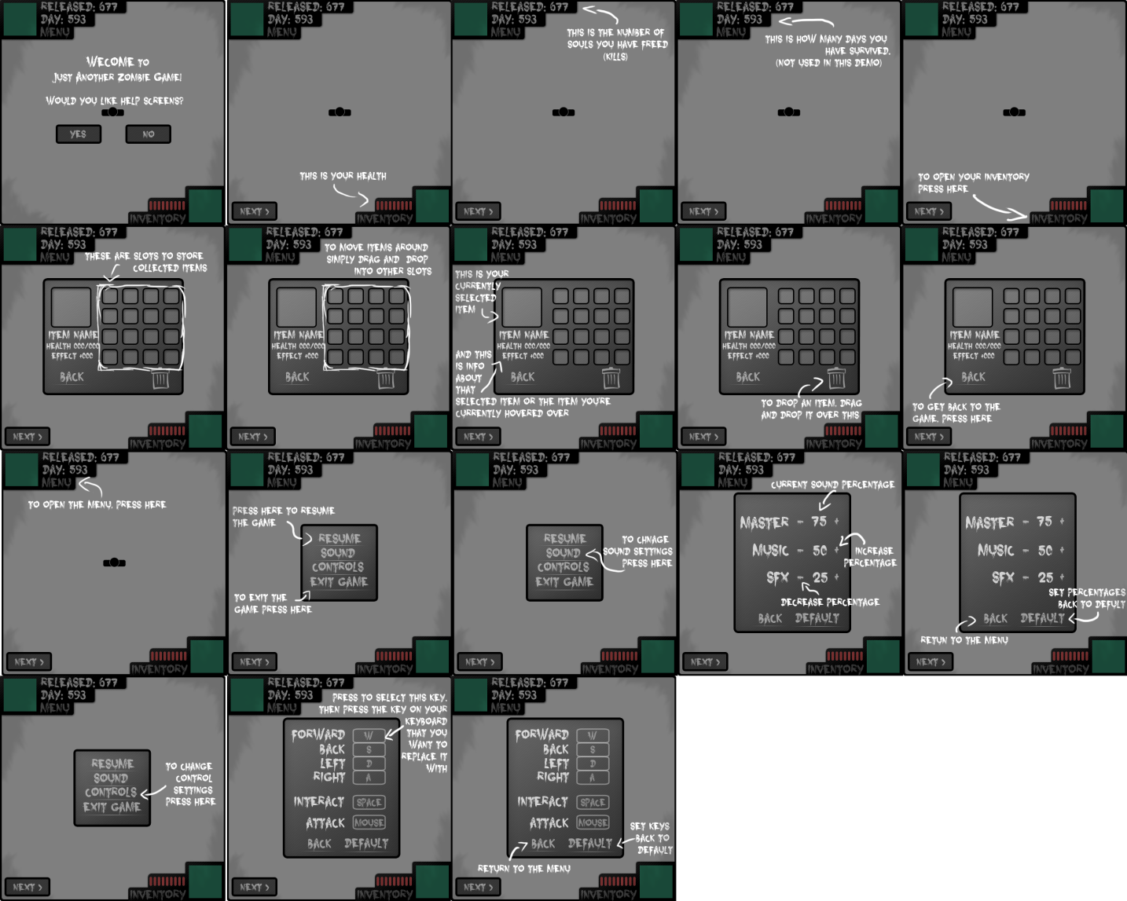
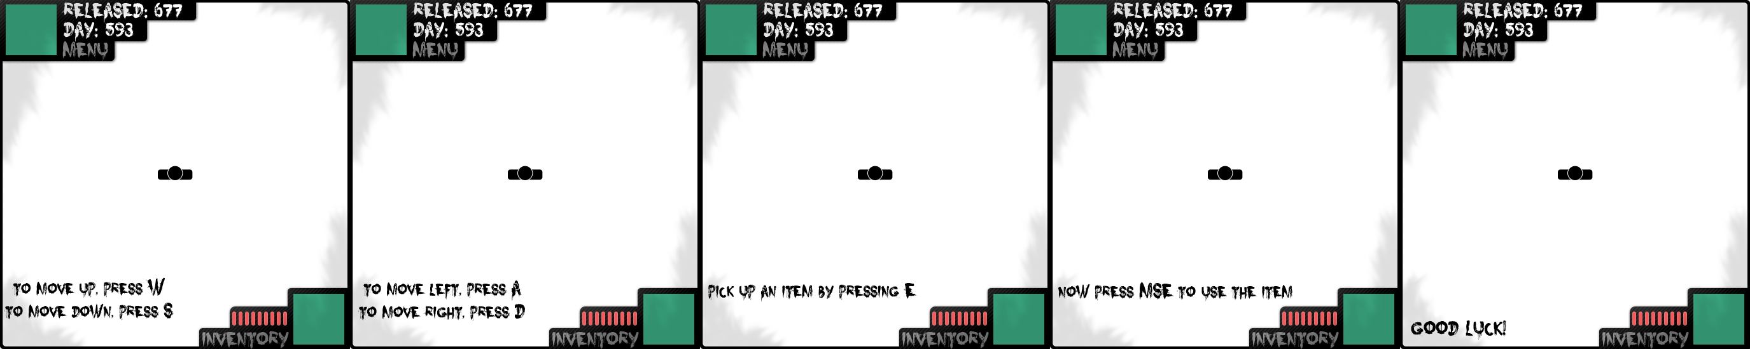
Once the user has seen all these screens, it then goes into in game help. These are just text commands that the user has to complete to remove/move on

Game Over

When the user dies this screen appears. There’s only a button that returns to the main menu.

Saved Data

Saved Games:
See as this is a demo I have chosen to take out the ability to save the game as there is no need for it. Hopefully this can be implemented by the admins on a later date.

Saved Options:
Once the user presses the back button on the Options Screen or the in-game menu, all altercations to the default option will be saved. For both sound and controls an array is saved using flashes Local Shared Objects (LSO). This work in the same way as cookies by saving data to the local computer that is using the program. This is method is only really good for storing preference as saved games can get easily deleted by accident. LSO can store up to 100 kb without user permission which the preferences will not exceed.

Sound data – This is simply an array of integers that stores three integer values as well as Boolean to show that the data has been created. This is all saved under the location name “SoundValues”.

Controls data – Similar to the sound data, an array of strings is used to store each key value. There is also a Boolean to show that the data has been created. The location name will be "KeyValues".

Test Strategy

Development Plan
When developing my game for the administrators of Knowlesy.co.uk I have come up with a general plan of how I will build the game. It goes as follows:
- Main Menu
- Main Mechanics for the Player
- Main Mechanics for Items
- Inventory
- Main Mechanics for the Enemies
- Main Mechanics for the Enemies spawning
- HUD
- Menus accessible from the HUD
- Level boundaries
- Graphics and Animations

Test Plan
For testing I am going to follow my Development plan and test each bullet point once I complete coding them. This way I know that each section works well before continuing onto the next part. I have produced a table of what I will need to be testing in each section. I will duplicate and fully fill this in once development starts and I have something to test properly.

Main Menu:
Main menu section has several screens as part of it so I have split up testing for each screen.

Main Menu Screen -
What Needs Testing? | Is Input Required? | Expected Result | Actual Result | Fix
Start Button | Clicking with the mouse | Runs main menu animation and Switches screen to the Start screen
 | Hovering over with the mouse | Highlights the text within the button
Load Button | Clicking with the mouse | Switches screen to the Load screen
 | Hovering over with the mouse | Highlights the text within the button
Options Button | Clicking with the mouse | Switches screen to the Options screen
 | Hovering over with the mouse | Highlights the text within the button
Website button | Clicking with the mouse | The users default browser opens and goes to http://knowlesy.co.uk/
 | Hovering over with the mouse | Highlights the text within the button

Load Screen –
What Needs Testing? | Is Input Required? | Expected Result | Actual Result | Fix
Saves |  | No saves should be load as the demo doesn’t allow it
Load Button | Clicking with the mouse | Does Nothing
 | Hovering over with the mouse | Highlights the text within the button
Delete Button | Clicking with the mouse | Does Nothing
 | Hovering over with the mouse | Highlights the text within the button
Back Button | Clicking with the mouse | Returns to the Main Menu
 | Hovering over with the mouse | Highlights the text within the button

Options Screen -
What Needs Testing? | Is Input Required? | Expected Result | Actual Result | Fix
Controls button | Clicking with the mouse | Switches screens to the Controls Screen and load in key values to text in selectable boxes
 | Hovering over with the mouse | Highlights the text within the button
Sound Button | Clicking with the mouse | Switches screens to the Sound Screen and load in values for the sliders, positioning the sliders as well
 | Hovering over with the mouse | Highlights the text within the button
Back button | Clicking with the mouse | Returns to the main menu screen
 | Hovering over with the mouse | Highlights the text within the button

Controls Screen -
What Needs Testing? | Is Input Required? | Expected Result | Actual Result | Fix
Forward’s Selectable box | Clicking with the mouse | The box shows that it’s been selected and allows key input
 | Any key press | Changes the text within the box and un selects the box
 | Hovering over with the mouse | Changes back colour to a grey
Back’s Selectable box | Clicking with the mouse | The box shows that it’s been selected and allows key input
 | Any key press | Changes the text within the box and un selects the box
 | Hovering over with the mouse | Changes back colour to a grey
Left’s Selectable box | Clicking with the mouse | The box shows that it’s been selected and allows key input
 | Any key press | Changes the text within the box and un selects the box
 | Hovering over with the mouse | Changes back colour to a grey
Right’s Selectable box | Clicking with the mouse | The box shows that it’s been selected and allows key input
 | Any key press | Changes the text within the box and un selects the box
 | Hovering over with the mouse | Changes back colour to a grey
Interact’s Selectable box | Clicking with the mouse | The box shows that it’s been selected and allows key input
 | Any key press | Changes the text within the box and un selects the box
 | Hovering over with the mouse | Changes back colour to a grey
Attack’s Selectable box | Clicking with the mouse | The box shows that it’s been selected and allows key input
 | Any key press | Changes the text within the box and un selects the box
 | Hovering over with the mouse | Changes back colour to grey
Back button | Clicking with the mouse | Saves all the text from within the selectable boxes and returns to the Options screen
 | Hovering over with the mouse | Highlights the text within the button
Default button | Clicking with the mouse | Changes all the text in the selectable boxes to predefined default text (W,S,A,D,E,MSE)
 | Hovering over with the mouse | Highlights the text within the button

Sound Screen –
What Needs Testing? | Is Input Required? | Expected Result | Actual Result | Fix
Master Slider | Clicking with the mouse | The slider follows the mouse until it leaves the sliders area or when the mouse is pressed again
Master Slider % text |  | Updates the % of volume as the slider moves
Music Slider | Clicking with the mouse | The slider follows the mouse until it leaves the sliders area or when the mouse is pressed again
Music Slider % text |  | Updates the % of volume as the slider moves
SFX Slider | Clicking with the mouse | The slider follows the mouse until it leaves the sliders area or when the mouse is pressed again
SFX Slider % text |  | Updates the % of volume as the slider moves
Back button | Clicking with the mouse | Saves all slider values and returns to the Options screen
 | Hovering over with the mouse | Highlights the text within the button
Default button | Clicking with the mouse | Changes all the sliders positions and % text to 75
 | Hovering over with the mouse | Highlights the text within the button

Start Screen –
What Needs Testing? | Is Input Required? | Expected Result | Actual Result | Fix
The frame changes | Clicking with the mouse | Next frame is shown
Skip button | Clicking with the mouse | Takes you to the final frame on the start screen
 | Hovering over with the mouse | Highlights the text within the button
Male Button | Clicking with the mouse | Goes into the game as the player being a Male
 | Hovering over with the mouse | Grey overlay appear over the button
Female Button | Clicking with the mouse | Goes into the game as the player being a Female
 | Hovering over with the mouse | Grey overlay appear over the button

Main Mechanics for the Player:

What Needs Testing? | Is Input Required? | Expected Result | Actual Result | Fix
Player rotation |  | The player should rotate to face the mouse
Movement | Forward key from saved key list being pressed | Everything on screen should move down the screen
 | Back key from saved key list being pressed | Everything on screen should move up the screen
 | Left key from saved key list being pressed | Everything on screen should move right the screen
 | Right key from saved key list being pressed | Everything on screen should move left the screen
 | Interact key from saved key list being pressed | A function that does not yet exist should be called, so nothing happens
 | Attack key from saved key list being pressed | A function that does not yet exist should be called, so nothing happens

Main Mechanics for Items:
What Needs Testing? | Is Input Required? | Expected Result | Actual Result | Fix
Item pick up when player is within range of item | Interact key from saved key list being pressed | The item gets picked up

Inventory:

What Needs Testing? | Is Input Required? | Expected Result | Actual Result | Fix
Open Inventory | Down arrow (temp before HUD is installed) | The inventory opens on screen and the game is paused
Items being able to be dragged and dropped to other slots | Mouse Press and hold | Current item goes into slot that it’s been released and if an it is already in the slot they swap
Displaying info about an item | Mouse over item | Info about the current item the mouse is over will be displayed
Displaying info about an current item |  | A current item should always have info about it displayed
Drop item button | Mouse Press and hold | Highlights the text within the button and remove item from the inventory and drop on the ground around the player
Back button | Clicking with the mouse | Saves and removes the inventory from screen and un pauses the game
 | Hovering over with the mouse | Highlights the text within the button

Main Mechanics for the Enemies:

What Needs Testing? | Is Input Required? | Expected Result | Actual Result | Fix
Rotation |  | They should automatically face the player when in range
Movement |  | The enemy should move towards the player as soon as they are in range
Attacking |  | They player should take damage when the distance between the player and the enemy is both their heights added together
Taking damage | Attack key from saved key list being pressed | They player will damage the enemy with the current items damage points
Check hitting Player |  | This will put the enemy into attack(See above) and stop the enemy from moving
Check hitting another enemy |  | The enemies shouldn’t overlap so they stop when they collide with each other

Main Mechanics for the Enemies spawning:

What Needs Testing? | Is Input Required? | Expected Result | Actual Result | Fix
Enemies spawning in intervals |  | The enemies spawn every second
Enemies spawn off screen |  | The enemies spawn at a random position off screen
Enemy types |  | Different enemy types should spawn at random

HUD:
What Needs Testing? | Is Input Required? | Expected Result | Actual Result | Fix
Kill counter |  | When the player kills an enemy the counter increases by one
Mini map |  | The map moves as the player moves
Health bar |  | The bar should show that damage has been taken
Current Item |  | An image and health should be displayed
Inventory button | Clicking with the mouse | Opens inventory on top of everything and pauses the game
 | Hovering over with the mouse | Highlights the text within the button
Menu Button | Clicking with the mouse | Opens In-game menu on top of everything and pauses the game
 | Hovering over with the mouse | Highlights the text within the button

Menus accessible from the HUD:
Main Menu -
What Needs Testing? | Is Input Required? | Expected Result | Actual Result | Fix
Resume Button | Clicking with the mouse | Removes Menu and un-pauses game
 | Hovering over with the mouse | Highlights the text within the button
Sound Button | Clicking with the mouse | Opens the sound menu
 | Hovering over with the mouse | Highlights the text within the button
Controls Button | Clicking with the mouse | Opens the Controls menu
 | Hovering over with the mouse | Highlights the text within the button
Exit Button | Clicking with the mouse | Remove all objects off screen and opens the main menu screen
 | Hovering over with the mouse | Highlights the text within the button
Sound Menu-
What Needs Testing? | Is Input Required? | Expected Result | Actual Result | Fix
Maters plus | Mouse Press | The Mater % text should increase by 1 if < 100 and > 0
 | Mouse Press & Hold | The Mater % text should increase by 1 every 10th of a second until 100 is reached
 | Hovering over with the mouse | Highlights the text within the button
Maters Minus | Mouse Press | The Mater % text should decrease by 1 if < 100 and > 0
 | Mouse Press & Hold | The Mater % text should decrease by 1 every 10th of a second until 100 is reached
 | Hovering over with the mouse | Highlights the text within the button
Music plus | Mouse Press | The Music % text should increase by 1 if < 100 and > 0
 | Mouse Press & Hold | The Music % text should increase by 1 every 10th of a second until 100 is reached
 | Hovering over with the mouse | Highlights the text within the button
Music Minus | Mouse Press | The Music % text should decrease by 1
 | Mouse Press & Hold | The Music % text should decrease by 1 every 10th of a second until 0 is reached
 | Hovering over with the mouse | Highlights the text within the button
SFX plus | Mouse Press | The SFX % text should increase by 1 if < 100 and > 0
 | Mouse Press & Hold | The SFX % text should increase by 1 every 10th of a second until 100 is reached
 | Hovering over with the mouse | Highlights the text within the button
SFX Minus | Mouse Press | The SFX % text should decrease by 1 if < 100 and > 0
 | Mouse Press & Hold | The SFX % text should decrease by 1 every 10th of a second until 0 is reached
 | Hovering over with the mouse | Highlights the text within the button
Back button | Mouse Press | Saves all the text from within the % tests on screen and returns to the Main Menu
 | Hovering over with the mouse | Highlights the text within the button
Default button | Mouse Press | Sets all the % text to 75
 | Hovering over with the mouse | Highlights the text within the button
Controls Menu -
What Needs Testing? | Is Input Required? | Expected Result | Actual Result | Fix
Forward’s Selectable box | Clicking with the mouse | The box shows that it’s been selected and allows key input
 | Any key press | Changes the text within the box and un selects the box
 | Hovering over with the mouse | Changes back colour to a grey
Back’s Selectable box | Clicking with the mouse | The box shows that it’s been selected and allows key input
 | Any key press | Changes the text within the box and un selects the box
 | Hovering over with the mouse | Changes back colour to a grey
Left’s Selectable box | Clicking with the mouse | The box shows that it’s been selected and allows key input
 | Any key press | Changes the text within the box and un selects the box
 | Hovering over with the mouse | Changes back colour to a grey
Right’s Selectable box | Clicking with the mouse | The box shows that it’s been selected and allows key input
 | Any key press | Changes the text within the box and un selects the box
 | Hovering over with the mouse | Changes back colour to a grey
Interact’s Selectable box | Clicking with the mouse | The box shows that it’s been selected and allows key input
 | Any key press | Changes the text within the box and un selects the box
 | Hovering over with the mouse | Changes back colour to a grey
Attack’s Selectable box | Clicking with the mouse | The box shows that it’s been selected and allows key input
 | Any key press | Changes the text within the box and un selects the box
 | Hovering over with the mouse | Changes back colour to grey
Back button | Clicking with the mouse | Saves all the text from within the selectable boxes and returns to the Main Menu
 | Hovering over with the mouse | Highlights the text within the button
Default button | Clicking with the mouse | Changes all the text in the selectable boxes to predefined default text (W,S,A,D,E,MSE)
 | Hovering over with the mouse | Highlights the text within the button

Level boundaries:
What Needs Testing? | Is Input Required? | Expected Result | Actual Result | Fix
The player stops when moving up into house wall | Forward key from saved key list being pressed | The player won’t be able to move in the current direction when touching the wall
The player stops when moving down into house wall | Back key from saved key list being pressed | The player won’t be able to move in the current direction when touching the wall
The player stops when moving left into house wall | Left key from saved key list being pressed | The player won’t be able to move in the current direction when touching the wall
The player stops when moving right into house wall | Right key from saved key list being pressed | The player won’t be able to move in the current direction when touching the wall
The player stops when moving up into the top of the map(1375) | Forward key from saved key list being pressed | The player won’t be able to move in the current direction when touching the boundary
The player stops when moving down into the bottom of the map(-1375) | Back key from saved key list being pressed | The player won’t be able to move in the current direction when touching the boundary
The player stops when moving left into the left boundary of the map(1375) | Left key from saved key list being pressed | The player won’t be able to move in the current direction when touching the boundary
The player stops when moving right into the right boundary of the map(-1375) | Right key from saved key list being pressed | The player won’t be able to move in the current direction when touching the boundary

Graphics and Animations:
What Needs Testing? | Is Input Required? | Expected Result | Actual Result | Fix
Player Moving | Any directional key from saved key list being pressed | The players legs should rotate to face the direction the player is trying to move
Player Attacking | Attack key from saved key list being pressed | They player should change animation state showing that it’s attacking
Player Dead |  | A death animation runs when player health is 0
Enemy Moving |  | An animation should play to show the enemy moving
Enemy Attacking |  | Enemy Attacking animation will play when dealing damage to player
Enemy Death |  | Death animation will play to show the enemy isn’t a threat

